Bank of England

Inflation Report

May 1994

Inflation Repor t

May 1994

Summary

Recent developments in inflation

###### .1 Retail prices Output prices Domestic deflators Core inflation

Summary 10

*Short-term inflation projections. the*

1. Monetary policy

###### Money and credit aggregates

* 1. Interest rates and exchange rates 18

Market developments 18

Rationale 19

* 1. Summary 20

*Divisia one year on 16*

Demand and output 21

Demand 21

The personal sector 21

The corporate sector 23

Overseas trade 25

Fiscal developments 26

3.2 Supply 27

Summary 28

The labour market 29

Earnings 29

4.2 Demand for labour 29

Unemployment and the supply

f I 30

32

4.5 32

* 1. The equilibrium level of

- unemployment

* 1. Outlook 34

1. Price dynamics
   1. Profitability

###### Terms of trade

Import and commodity prices Export prices

5.4 Summary

###### fi Prospects for inflation

3.6

###### 36

38

39

40

41

42



|  |  |  |  |
| --- | --- | --- | --- |
|  | 6.1 | The Bank’s medium-term inflation |  |
|  | projection | 42 |
| 6.2 | Uncertainties affecting the projection | 44 |
| 6.3 | Private sector inflation forecasts | 44 |
| *Box* |  | *Medium-term inflation projactions:* |  |
|  |  | *the.track record* | *45* |
| 7 | Conclusions | | 47 |



‹JB%k#Eñ ñB.994





Summary

The Government’s target measure for inflation—the 12-month change in the retail price index excluding mortgage interest payments (RPIX)—has again fallen over the past three months, from a rate of 2.79c in December to 2.4& in March. The rate of **RPIY** inflation has fallen below the RPIX rate, to a level of 1.99 in March. Annual M0 growth remained well above its One—4% monitoring range at 6.2 in April and M4’s annual growth rate was near the centre of its 3&«—9% monitoring range at 5.9% in March. But, for the moment at least, this is not a cause for inflationary concern. Since early February. financial markets have seen substantial movements worldwide. The United Kingdom has been particularly affected. The expected inflation term structure has risen quite sharply and suggests inflation above 4% for the period from 1996 to early 2007. The growth rate of output has probably risen slightly above trend. Over the short term, consumption growth is likely to weaken, as consumers respond to the latest tax increases; but investment may strengthen as the persistence of recovery becomes clearer to firms. Nominal earnings are rising more rapidly than last year. It will be necessary to monitor labour market developments extremely carefully over the next few months. Profitability has continued to increase. Cost increases remain subdued.

Since changes in monetary policy take time to affect output. employment and inflation, it is necessary to form a judgment about the direction in which inflation is headed over the next two years or so. On the.assumption of unchanged interest rates, the most likely outcome for RPIX inflation two years bence is 3&m3.She, and for RPIY inflation just under 3&. There are, of course, large margins of error in any such projection. The main

risks to the inflation outlook are threefold. First, rates o1 monetary growth have continued to increase. Second, inflation expectations nave risen and are no longer coming down into line with the inflation target. Thief is the rise in the growth of underlying



.average.earnings:

T .





**RFTY**

The Government’s target measure for inflation—the 12-month change in the retail price index excluding mortgagC interest payments (RPIX)—has again fallen over the past three months, from a rate of 2.7% in

###### .December to 2.4% in March, the lowest figure since the index was first compiled in 1975 (see Chart 1.1 ).

— e

The RPIX measure includes increases in indirect







Chart 1.2

**Goods** rind **services** inflation

, taxation. The Bank’s RPIY measure excludes both local authority and indirect taxes, as well as mortgage interest payments. ' (2 Sifl ce NOV€lmber, the rate of RPIY inflation has fallen below the RPIX rate, to a level of 1.9% in March.

Headline RPI inflation includes the effects of changes in mortgage interest rates, so it can diverge from RPIX inflation for a considerable time; it has been lower than RPIX since early 1991. It reached a low point of 1.2% in June 1993. Since then, large cuts in mortgage interest rates in 1992 and 1993 have dropped out of the 12-month comparison, so RPI inflation rose to 2.5% in January. It fell back to 2.3% in March. From April, the reduction in the rate for mortgage interest tax relief from 25% to 20&o will raise the headline rate of inflation further, pushing it above RPIX inflation.

Over the last couple of years, increases in goods prices  have been more variable than the prices of services.

Goods price inflation fell sharply towards the end of last year as competition between retail outlets— especially supermarkets—intensified, but it is now back to broadly the same level as in early **1993** (Chart 1.2). Services inflation has continued to fall. Sales and

.special promotions cause prices to fluctuate, giving

- 2 peaks and troughs in inflation associated with seasonal sales. Chart 1.3 shows that household goods prices fell more this January than in the previous three years, but rose **in February and** Mârch by broadly the same



t1), Th e.ca1cul ñtion.of RPIY! has been revised in:this }tepont to incorporate.more disJij•égated..datâ .on.taxes:and duties.

:t2) RPIY.inf1atiob iiiai''.strange it,a different rare from RPIX even when tax

**cltanges-.conoibuti nothing.to RPDi** inflation, This is.because!the weights



kPIY than

prices change, RPN will m‹ive differently

fB0m'RPIX‹.'ev’en:if taxes remain:conctaot:



L'hart 1..T

'st'Asnna1 nyuvc›ncnts in pricus uf household

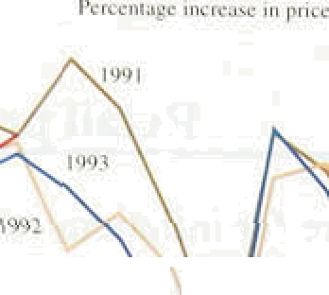





I ’lix rt 1.4

'seasonal n **‹»'en ents in prices of clothing and f'nntH'ear**

Rnvugtirmmminp1•sonamonllca

4

— 1994









**Table** 1.A

**Short run measures of inflation**

amount. By contrast, clothing and footwear prices rose much more strongly i.n February this year than i!n the previous three years (Chart 1.4),.though. this higher increase was unwound in March.

Table 1.A shows how short-run measures .of inflation (annualised changes in prices over three months) have varied over the past year. Short-run inflation measures can give an early indication of changes in inflationary trends, although they are sensitive to changes in seasonal patterns and to temporary clisturbances. The figures for RPIY inflation since the last /nfJafion *Report* point to an acceleration of prices.

To isolate the new information contained in price statistics. each *Inflation Report* includes short-nin inflation projections for up to three months ahead. against which the actual figures can be compared. The projections are basically statistical extrapolations, adjusted for known price increases {eg indirect taxes). The 12-month measure of RPIX inflation in March was very close to the projection included in the last *Inflation Report,* although prices fell more in January and .rose more in February than foreseen. Chart 1.5 shows the new short-run ection. It takes into account the imposition of CAT on domestic fuel and power from April, and the dropping-out from the 12-month comparison of last year’s switch to the Council Tax and last April’s .increases in duties. The box on pages 8—9 examines the track record of the short-term projections of the Bank since the first *I*n*flation* fteport in February 1993. The mean absolute error of the Bank’s



one-month-ahead projection, at 0.1.8 percentage .points, has been lower than that of tlie market’s. average forecast (0.23 percentage points)„. Both have tended to be further off the mark in */o/fafiori Report* months than in tire other eight months of the year,

#### 2 O t

The .12-month change in. output pnces for all

RPI RPIX RPIY Gon.de Services

C

to 3 4 » in ebnd '1994

* fh

t

4 6)'

e index' *





Mar, j993 0.9 3.8 3.'/ 2.3 5,7

 ]’.0 2.8’

Sept 1.993 3:9 4.1 3.5 2.9 3.9.

Feb. j994 3.2 3.8 i,8

j9g4 2:4 :3:0. 2. I

includes the effect ofichanges in indi ect taxes on.

.tobacco, alcohol and petroleum.. rrices to* all industries

##### apart from food, drink, .tobacco aird petroleum rose buy

.2.5% in the year to February, compared with nn increase

:Chart 1.5!

**.RPIX inflation** p







Tlie muted rise1in producer prices is also reflected in The April quarterly survey found 1&o

more. firms expecting to lower domestic prices than to



.increase them over the next four months, compared with a balance of 10% expecting to increase them a year ago. Manufacturers’ price eKpectations have remained fairly

flat since June last year.

### _ _ 1.3 Domestic deflators

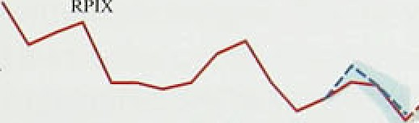

The consumption deflator at factor cost provides an

- 2



**Ch'art 1.6**

**Producer output price inflation**

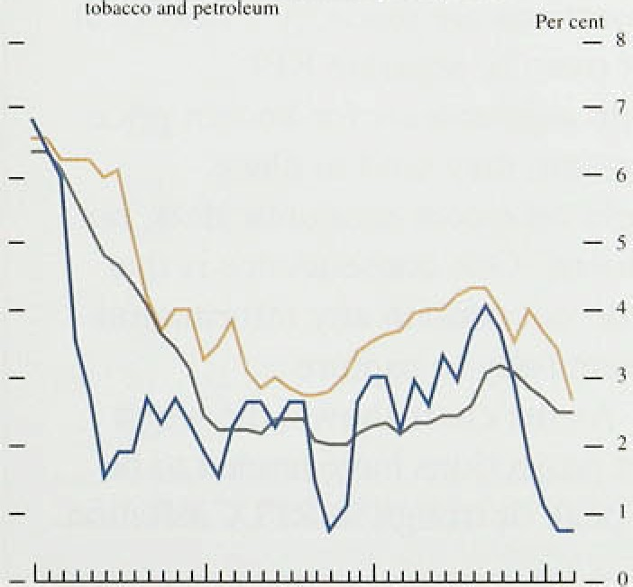

**Tablei 1.B:**

**Domestic ideftators•••-e**xpenditure componentc

”Pcrceritage. changes!.on a ..earlier



alternative measure of inflation faced by consumers; the measure was stable at around 3'/z% to 4% for the final three quarters of 1993. Table I.B shows the evolution of the component deflators of **GDP** (expressed at factor cost). The consumption deflator rose by 3.7% in the year to 1993 Q4, compared with 3.9& in the same quarter a year earlier. It rose about one percentage point further than RPIX in the year to 1993 Q4. It is unusual to have a sustained gap between the .two measures, though there was a large difference in the early 1990s when the Community Charge (included in **RPIX** but not in the consumers’ expenditure deflator), replaced local authority rates (which had been included in both).

The GDP deflator is the most comprehensive indicator of domestic inflationary pressure. It is, however, published with a .lag, can show sharp quarterly changes and is sometimes subject to large revisions. It rose by

4.8% in the year to 1993 Q4, up from 3.ldc in the year to 1993 Q3. The rise of 1.79r in the GDP deflator in the fourth quarter mainly reflected faster increases in the deflator for consumption, but also partly reflected the

.arithmetic ,effect of the fall in import prices during the quarter: It tâkes time to pass higher import prices. into final prices, so that in the short run the rate of change of the ODP deflator will be inversely related to changes in import prices.

In the year to 1993 Q3, deflators for exports and imports both rose much more quickly than the GDP deflator as a whole, reflecting the effects .of the depreciation at the end of 1992. In 1993 Q4, however, the rise in import pnces between the third and fourth quarters of 1992

annual change, so that import price i!nflation. dec1.ined to .1.8%. The deflator for government



3.1% i:n the year to 1993 Q half



8 point higher than.in the previous quarter



#### bur.sai.r:ae,.rate of a.year earlier„ ref1ecting constraints

. The ‹deflator for investment has



##### recenil.y.: gistered smalllincreases:following almost two



7.



**Short*term inflation projéctions:** thq **track record**

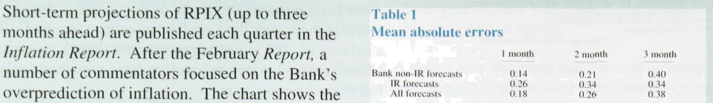

picture m:isi iised. to illustrate the point.

ill:irkui n‹›iy•tR In‹›nIIys IR m‹›ntI›s

.projections: For tone-moñth-ahead projections, two concl:usions are’ apparent:

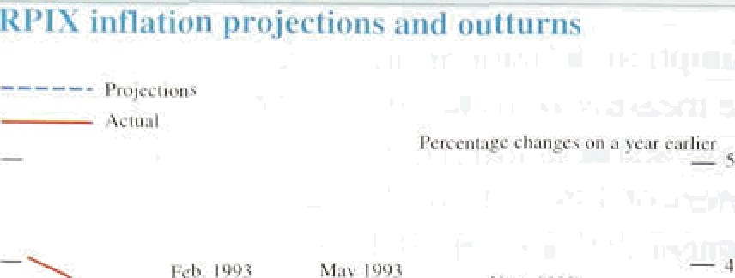

the Bank .has a worse track ;record with i!ts. projections mafie fi›r.the.Infl*ation. Rep!ort* than witli projectiofis in other inoi:ths; ,find

the market .forecasts on average had a. greater margin of error.than those,.produced within.the.Bank, and their difference between *Infl.ation Report* months and other’ months was even larger.





Tañle 2 opposites records the sequei ce of

tliree-month!piojections!.made since 1:anuary. last year; together wittt the. Money Market Services rriedian..(market) protections: for one month ahead: To sumrnarise,this, Table 1 reports the. average absolute error of the Bank and.market.

The Bank's projections are.rñade.by a statistical extrapolaticin of over 20 sépafatg RPI components, with adjustments for known price changes. .As a result, tiiey tend to place

.substantial weight on recent economic’data, .not economic!Judgment. Elne.consequence is that the projections do not contain any information which alldws them fully to capture

turning-points. As the chart,shows, the worst *Inflation .R‘e po\rt.* projections have tended.to be made at.a local peak or trough .in.RPIX inflation.

I'I : rt I.7

*.\ I* ttri atis”t njt;l urex ‹›f” *c‹›rc' infl»tinr



### 1.4 Core inflation

Over:short periods, shocks affecting particular prices can cause measured inflation to deviate from the underlying rate. In judging the latter, it is useful!.to look at measures.of ‘core’ inflation which exclude, one-off changes to the price level.

: 7

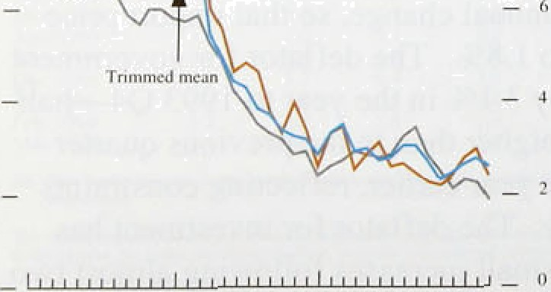

s a s h tl

h' ' p o! R

e ifldices

,8.

to compute a. median 12-month change for each !period, thus, giving no weight to.extreme movements in relative prices (see the May 1993 *Report).„* The seconñ.excludes. frory!the calculation the largest relati.ve price changes. and c3lculates the’average!changqiof all the remaining.



For three-month projmtions, the:0istiyetioii between IR'and non.-IR proj tioristdisappears, as they have,.both tended to encompass

##### turning-points.:

However, **the,Bank's** statistical procedures allow for the extrapolation to reflect recent patterns with more weight. Sao the.rathei unusual

short-term cycles that.have been seen will start to be reflected in’future projections.

The Bank’s track'record withiits short-term projlection rriight prompt the question: why try to forecast two years. ahead, given the problems forecasting even one.month in.advance?

###### The slioit-term:. projlecltion is a statistical

construction.that embodies no:economic

Table 2

RPI X forecasts and ucluiils

.theory—the. noisé in monthly.!data’m es it moye difficult to ryognise the fundamqntals. It,is perfectly consistent to have more fai!th .in.’the longer-térm quar"terly projéctioiis.

Why then produce a short-te.rm projection? As a statistical device, tlie three-month projection vs a useful.reference .path against which to judge the news in actual inflation data. .Since October„ inflation has, most often been below forecast..

On further investigation, this has proved to be due in part to significant downward pressure on inflation from increased competition among supermarkets. The projection error was a useful. device for spottirig new .developments in the int’lation environment. To focus on the errors is to miss the point—which is how best to extract the news from the numbers.

Actuals BE'’". I-eb. Mar. Rpr. May I uoe RU'







components—a ‘trimmed mean’. During 199 I and 1992, both the median and the trimmed mean inflation rates were well above RPIY inflation. By mid-1993. **RPIY** inflation was above the measures of core inflation, but towards the end of the year the three came more closely into line.

**RPIY** and RPIX measures both exclude mortgage interest payments to avoid distortions .caused by chanp•es in interest rates. This has the effect of totally excluding housing services consumed by owner-occupiers from these price indices. The price of these services may

well change if, for example, house prices rise. The housing-adjusted **RPI** (HARP index) replaces the mortgage interest coinpofient of the headline rate with an estiinate of the user-cost of .housing (see the

9



kPl, TPI and II.xRp inflation i'utes



— 4



###### February 1993 ***Re!port),*** The Halifax house price index employed in the user-cost measure,began to rise, in the middle of 1993. In March this year, it was 2.6&• higher than a year earlier, whereas.mortgage interest payments were less than l% higher. At the end of 1993, the HARP index showed inflation at2.4%; this picked up to 3.0$• in February 1994 but fell to.2.5$r in March (see

Chart 1.8). The TaK and.Prices index (TPI) adjusts the RPI to compensate•for changes in direct taxation. This index tracked the RPI very ctosely during the second half of 1993 but is likely to rise above it in April, because of increases in income tax and national insurance contributions.



Twelve-month RPIX inflation has come down from around 2'/4% at the start of this year to below 2'/i% in March. Other measures of inflation—RPIY, the retail sales deflator, the median and trimmed-mean versions .of the RPI—Suggest the same story: inflation has continued to fall. But the consumer expenditure deflator and the HARP and TPI indices have registered an increase, as has RPIY when measured over three months instead of 12. The Bank’s short-run projection is of a small increase in RPIX inflation as a result of thK

effects. The squeeze in retail margins seen at the.end of last year is not expected .to be repeated.



## e2q1n Mo

t a e te



The growth rates of both narrow and broad money have continued to rise since the last *Report.* Annual M0 growth remained well above its 0%—49 monitoring

range at 6.2% in April and M4’s annual growth rate was

near the centre of its 3%—99c monitoring range at 5.99o in March. Lending, on the other hand, remains subdued. Since early February, there has been turbulence in world financial markets, particularly in bond markets. Market interest rates at all maturities have risen markedly.

Since monetary policy accommodates shocks in the demand for money in the short run, movements in the monetary aggregates often provide timely indications of trends in demand and activity. Sometimes the

aggregates will reflect also developments in the financial markets or portfolio re-allocations. Both real and financial factors appear to have influenced the monetary aggregates over the first quarter.

MO’s provisional 12-month growth rate fn April was 6.2&». Moreover, its three and six-month annualized growth rates in April—at 13-1% and 9.1la respectively—suggest that further increases in the annual growth of M0 are possible (but it should be noted that the precise numbers are sensitive to the method of seasonal adjustment used). Monthly changes in M0 continue to be rather erratic—its 12-month growth rate fell from.5.9& in December to 5.1*to* in January, rose in February to 5.4% and in March to 5,6% and then rose strongly in April to 6,2&o. Some of these fluctuations can be attributed to movements in bankers’ balances at the Bank .of England. The monthly growth rate for notes and coin, a better indicator of underlying narrow money, averaged around 0.596 between November and March.

###### On an annual basis, notes and coin growth increased

.from 5.78t› in December to 6.596 in April.

.Although month-to-month variations in narrow money growth tend to obscure its underlying implications for ipilation, tlie Bank’s current view is that the recent

###### g wtb in MO has limited inflationary consequences.





lrinatiou Report: My 1994

reflect an adjustment of cash balances towards a new equilibrium determined by i:nterest rates and real..output.

The fall in nominal interest rates over recent years .has reduced the opportunity cost, and hence raised the desired level, of cash balances. It has also lowered.the

.equilibrium growth rate of narrow money velocity. Bank research suggests.that the .trend growth rate of narrow money velocity is approximately proportional to the average level of interest.rates. So,.if, for example, average interest rates in future were.half their average

over the past 25 years, M0 velocity growth could also be expected to be around half as large—at say 29a a year— compared with a trend rate of around 4% between 1970 and 1990. The present increase in M0 .growth can therefore be explained, at least in part, as an adjustment to a new lower equilibrium velocity growth rate.



1 _- isionth Rriiss th rates of’ NI11, hI4 ii nd





Nf4

###### In addition, although the economy has grown for almost two years, the *level* of real output remains below trend. As a result,. average output growth should be expected to be a6ovr its trend at some stage; so should narrower

" measures of spending, such as retail sales. Since the

, level.of M0 is related to the level of retail sales, above-trend retail sales growth should be reflected in

° above-trend M0 growth—as currently observed.

Clearly, both these effects will unwind as narrow money

* + adjusts to its new higher-trend velocity and the output

, gap is closed. Thus, in the absence of further shocks, the longer M0 grows at well above the top of its monitoring range, the greater the concern about the.implications for

, future inflation.

After reaching a trough 1of 3.4% in 1993 Q2, the annual growth rate of M4 has increased for three consecutive quarters and stood at 5.9& in March, the highest since March 1992 (Chart 2.1). On the other.han‹i, lending by banks and building societies remained rather subdued in the first quarter. Its annual growth rate fell:from 3.6&o in December to 3.49. in Starch, and its annualised three and six-month growth rates then stood at 2.9&o and 3,.2% respectively.

One of.the main.difficulties in interpreting broad!rnoney I.igures is the.diversity. of motives for.holding.M4.

Broad:money is botb,spent.and.saved.so tiiat, in. principle, a given level.of M4:is consiatent with a.1arge riumber of consumption and.saving combinations.

Fnrtherrnore„changes 1n demand for broad monqy are affected m9ie by differencei betw.ecu.alternative rates of





Charl 2.2

Counterparts to M4 growth





I

returñ than by the absolute rate of interest. It is therefore helpful in considering M4 growth to look at its counterparts and its sectoral components. Counterpart analysis can help distinguish what is driving the

balance-sheet expansion of banks and building societies.

Likewise, sectoral analysis helps to distinguish between different types of agent with different saving and spending propensities.

* + Within the counterparts. the public sector made a
  + significant contribution to M4 growth in the first three

» months of 1994 (Chart 2.2). The public sector contribution **(PSBR** net of gilt sales to the M4 private

, sector) totalled £9.2 billion in the first quarter compared

, with £4.7 billion in the previous quarter. To a large

, extent, this reflected net disposals of gilts by the M4 private sector in the face of recent bond market turbulence. Total external and foreign currency flows

- 2 made a small negative contribution (£0.8 billion) to M4

— 4 growth in the first quarter, following a positive contribution over the previous quarter.



M4 growth in the first three months of 1994 was largely contained in its wholesale component, in contrast to the second half of 1993 when the growth in M4 was fairly evenly divided between retail and wholesale deposits. In the first quarter of 1994, the 12-month growth rate of wholesale deposits increased to 6.4% in March from 5.99c in December, whereas the rate for retail deposits was 5.4% in March compared with 5.1% in December.

Personal sector holdings of M4 rose by I.0% in the first quarter. Within this, there was a large build-up of bank and building society deposits by unincorporated businesses—fil.2 billion compared with £0.3 billion in the previous quarter. The increase in deposits held by individuals, at £1.8 billion, was the smallest rise since 1981 Q4. This was not completely unexpected, given the competition during the quarter from other

investment vehicles—for example retail unit trusts—and the prepayment of fuel bills (estimated to have totalled in the region of £1 billion). .In addition, individuals may have run down their bank and building society deposits to finance expenditure, which remained robust during the quarter.

Both industrial and commercial companies (ICCs) and other financial institutions (OFIs) are active and

. sophisticated.investors, **allocating** funds across a portfolio of assets in which M4 deposits are only one component. This makes it difficult to deduct the











»s '›2 st v4



C“hart 2.4

C’onipr›nrnts of pris'ale **sector financial**

lialance

Pcrce ntsgc of ii'oniin aI GOP

implications of.changes in corporate M4 for real activity, since they may also reflect portfolio substitutions. ICCs increased ttteir M4 deposits for the third successive quarter, by £3.5 billion, a strong rise of 4.4%. Some of this increase is explained by the prepayment of fuel bills being held on deposit by the utility companies. More importantly, however, M4 deposits may have acted as a safe haven during the recent financial market turbulence, with corporates mpving out of capital-uncertain bonds and into capital-certain deposits. The strength of ICCs’ deposits—and thus, to an extent, of .M may therefore be eKpected to unwind as the markets become calmer.

ICCs have repaid borrowing .frDlTl banks and .building societies in each of the last five quarters (Chart 2:3.), However, at £1.4 billion, the.value of the debt repay.ment in the first three months of 1994 was not as .high as the



,' record £2.2 billion in the previous quarter. As in 1993, ' ICCs’ .recourse to .capital markets has continued to be

' strong. The buoyancy of the equity and bonfi markets in 1993 provided companies with a relatively cheap.source of external .funds. More surprisingly, the sharp decline

, in UK equity and bond prices appears not to have diminished ICCs’ willingness to fund from these sources; net sterling capital issues in the first quarter of 1994 were £0.5 billion higher .than in the final quarter of last year. **ICCs’** total sterling borrowing (including capital issues and commercial paper) increased by

£2.7 billion in tire first quarter of 1994, compared with

£1.1 .billion in the previous quarter.

The steady improvement **in ICCs’** financial balance since 1991 continued through 1993 (Chart 2.4). In the

B.0



- 4:0

- - 2.0

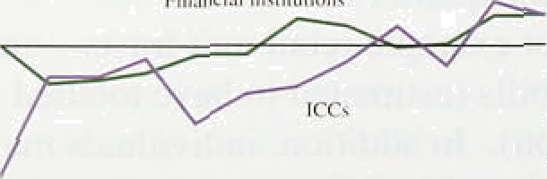

- 6.0.

I gy] 92 93

year as a whole, their financial deficit was eliminated for the first time since 1987. This pmcess of balance-sheet repair (increased assets, reduced liabilities) appears to have continued into 1994. But although ICCs’ income gearing has fallen considerably as interest rates have been reduced, their capital gearing remains at unprecedented levels. As long as this is ,the case, income fearing will remain more sensitive to upward interest rate movements than it has been hithérto (though sensitivity falls aS debt is repaid). Thus interest rate iincenainty may be serving as a brak on investment-led recovery.,

###### used the proceeds from bond and equity sales to repay bank borrowing.



Credit from banks and building societies constitutes a much larger proportion of the total liabilities of small firms and households than of companies, because these

##### agents are, typically, less able to draw on the capital markets for funds. In principle, therefore, credit should provide information on the personal sector’s actual and

potential spending.

##### Bank and building society lending to the personal sector increased by 1.4% in the first quarter, compared with l.2&o in the previous quarter (which would have been stronger had it not been for several securitisations that had the effect of removing some existing loans to the personal sector from M4 lending). The gently rising trend in lending for house purchase seen during 1993 continued in the first quarter of this year—the

12-month growth rate for house purchase lending increased to 6.39«. Bank and building society new commitments totalled **£13.6** billion in the first three months of 1994, compared with a quarterly average of

£12.6 billion during 1993, suggesting that the modest housing market recovery will continue.

###### After adjusting for the effect of securitisations in previous quarters,.lending for consumption remained broadly unchanged in the first quarter. Borrowing by unincorporated businesses rose £0.2 billion in the first quarter, .following a net repayment of £0.5 billion in 1993. If sustained, this rise in borrowing might indicate that the scaling-back of these businesses’ liabilities may be completed. Future income may be used for spending (including investment), rather than to repay existing debt.

The Bank’s Divisia index rose by 2.ldc in the first quarter of 1994, compared with 1.4&o in the previous quarter. Its growth rate (on a four-quarter basis) increase4 for the fourth consecutive quarter from its trough of 2.1&» in the first quarter of 1993, and currently stands at 5.9&o (see box on pages 16—17). Growth came from both the personal and corporate sectors, with particularly strong growth in.corporate Divisia.for the **mmd quarter in succession.**





Divisla .one year on

I tr Miiy lasi year, the Bank publisbed an articles w.hich assessed .Divtsia measures.of mon’ey:

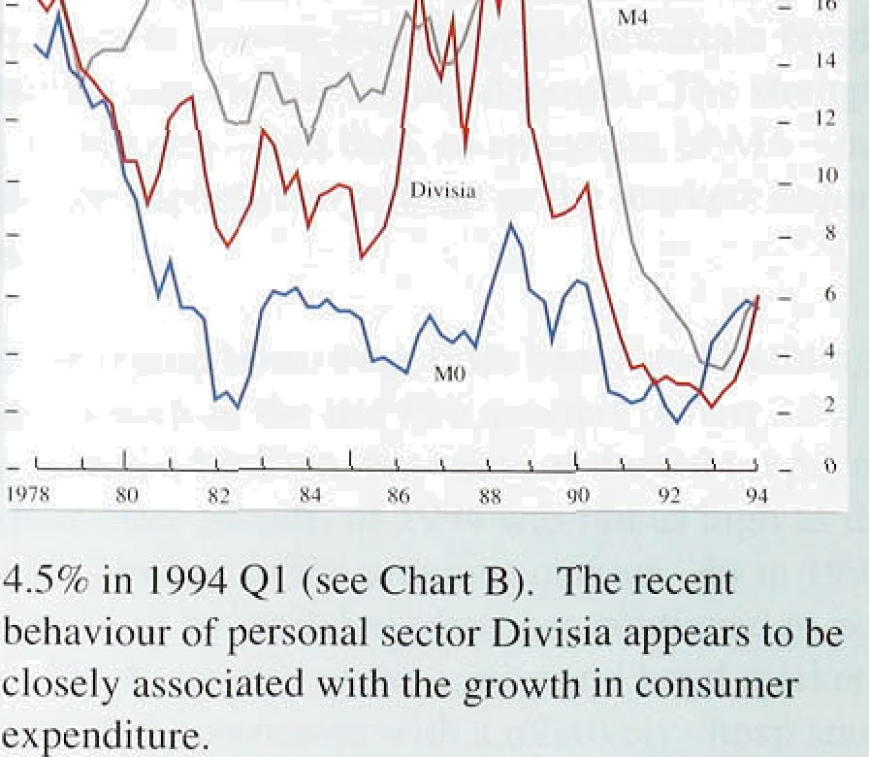includi ng. the,theoretical<irginneiits for a D.ivisia index. The article alto de:scribed the construcilon of a Divisia inddx for the}United'.Kingdorti and in:vestigateiJ the ’i.ndic5tor properiiés! of:?such an index.

The Divisia measure of rfioney attempts to allow for the varying transactions properti'es of the different monetary assets! within M4 by weighting thése according ti› their transactions characteristics. The weight of each cnmponent depends on its. size relative to other components ofi M4 .and on its ’user cost', which is the différerice between the rate or’ interest the component asset ofers ‹ind the return on a benchinarK,asset that is. assumed to offer no trans*etioiis services.

If lhese weights reflect differences in the transactions services provided by the various

monetary assets, then the re.stil.ting Divisia index t’hori H

will provide a better measure of lhe tolal quantity ot .4 nnuiil grriwl h r;itcs of’ pers‹›nal sert‹ii Divisin :irul money held in the economy for transactions services F**• °* *°* " *

than M4, much of which is thoughl to be held *i“or „„„*

savings purposes. I n principle, therefore, such an "

index should be more closely related than

.corrventional simple-sum monetary aggregates in expenditure in the economy. This .box looks at fievelopiñefits..in Divisia .over the..past year.

Cbart A shows the!annual. growth rates for M0, M4 and (aggregate) Divisia, wfiich now incorporates .an improved rrietliod of fireak adjustment: After reaching a trough•of 2..!.Or in..19931 Q1. (compared with lows in .1992 .Q2 and:.1993! Q2 .for M0 and M4 respéctively); the annual growth Sof Divisia h s. since increased .for four consecutivé gutters..and

currently ‘stands ai 5.99c. The quarter-on-quarter growth in 1994 Q l,.at 2.19c, ivas the highest.rate since/1989 Q4.

Growth in’Aggregate .Div!isia during 1993 was

/largely explained.by the:personal. sector. .The.annual!



The-growth in corporate sector Divisia, on the other, hand, did not réach its'recent .low.until 1993 Q3, Chen it recorded a negative annual growth rate. In the final quarter of 1993 and the first quarter of 1994, however, corporate Divisia.rebounde‹i

.sharply its quanerly growth rates were 4.0?f› and

growth rate of personal sector Divisia reached iti 4.1& in Q4 and Q1 respectively, pmducing an low poirit in 1992 Q3 (earlier than..the.aggregate **:dRnttâl** rate.of 10.9& **.(see Chart C). .National**

i ndex).afid .has.since exhibited an.upward trend—the. ,accounts ‹rata:show that **compan:res** have been slow. annual growth rate of.personal sectpr Di.yisiâ wâs **tO 'ifiCf€lase :in** estment **dining** the recovery., **Tlie**







**A iinual growth** rales iJ rorp‹irule scrlrir Hi s isiii **anil**



.sliarp g.rpwth, in.corpofate .Divisia in 1993Q4 is ‘consistent with:the upward revision to investment in the latgst fourth qu iter dati.

Compariiig annual growth rates *for* disaggregate‹J

.Divisia witf; tlidsectofal components of M4 shows

.that.the relationship betweem personal sector Divisia

.añd personal.sector M4 is .fairly close. The differencé between the! two.series is related to the savings element of M4,. which is excluded by Difiisfa: Personal sector M4 reached its low point in 1953 Q2; three quakers later than personal sector Divisia,.and has subse.quently increased much less rapidly: This.is, pefhaps, consistent.with bank and building society..tifiie.deposits held by the personal sector.for saviqgs purposes being adversely affected by the fall in the personal sector saving ratio and increased competition froiii other'sa*ings vehicles

:ou!side .MMfor example retâil unit ;msts: The growth in personal sector Diâisia;.on the.other hand,

.probably reflects the growth in notes:.and coin, and fin..inctease in.the demand for transactions.

4iepo8it ñoth of whicli.receive a high.!vwei.ght. within %ivisi,a re/lgt@ to the uptu;yi in {eJail Tales.

Corporate seétor M4 grciwth (proxied by a simple average.of ICCs" and OPls’ growth .rates) is lerrptic compâred with personal sector M4 growth. -This can‘ be explained. by both ICCs’ ând i3Fls’ reldtively small and somewhat variable holdings of M4 **deposits. Corpmate D.lvisia exhibits,an,e en** more **volatile** growth **pay wiiich** suggests that **confining n«osécdons balances to** M4. **components** may not be



exaiiipl art .more'1ikely to be’ seen as liquid by the corporate sector.:

'The construction of Divisia allows inoney derñand. equatioñs to ñe estimated based on well-establis hed

.theories of the! trñiisactions demand for money. In the Bank!.s.work l t year, the trend!coinponent withifi. Di.vista was!explai.ned ñy. prices, real activity and user costs; with ari assumption that al.l changes in the price level eventually lead to equal percentage changes in Divisia.. The dynamic adjustment to this trend was gradual, and was, influenced by output growth and inflation. For Aggregate and personal sector Divisia, this type of model was found to work well, but the corporate sector results were less convincing.

Recent Bank research suggests that the personal sector Divisia model continues to work well when extended over an extra year of data using the .new break-adjustment method. The money demand equation is reasonably stable and passes standard mrs-specification tests. But a stable relationship for the corporate sector is still elusive. This, in turn, creates problems when attempting to model aggregate Divisia. The long-run trend relationship is not precisely determined and the dynamic relationship fails some of the standard tests-the error *term* may be *non-normal* and the equation has a high standard error—raising concerns about.the

equation’s stability and predictability. .Tlie corporate

sector’s increasing use of the capital markets throughout 1993 and the first quarter of 1994 provides a possible explanation fOr the ,deterioration in the corporate Divisia equation.

What are the .implications ofi the recent .growth in Divisia for inflation? The relatively'stable .growth of personal sector Divisia last year appears consistent with.developments iii the real,economy during the peno‹i. Corporate:sector Divisia is

difficult.to.judge as. a!guide›to potential inflation pressures «s corpomte portfolio allocation is not well understood. Up to 1903 Q4. the growth in. agitegate Divisia was largely exp1aine‹i by tlie

.personal sector. ,.The strong growt1i in aggregate Divisia in .the last six months, on the:other hand, was also relatad,to corporate sector behaviour; whicli itself migftt.simply, represent am ovéradjustment to weak. activity in previous quarters, So, in the absence of further data, reient Divisia growth

should not give rise to inflationary fears.

17





t!nilcd Sistcs:

Prime mo h.tits I›.00 6.0tl. G.(IU 6.HO 6.75



Fra nee:

Info r ciiitun J 6t1 9.1 O fy.75 h.4fi ft. 20 5.70

,— ltl duj' rcpri l tk 30 l 3.HH 7.7fi 7.25 7.fj0 fi.75











change› _ (pewentaj2e rhange )



Uniic‹t Slates I *5 -6.8 -2.2



France i2 i •7.b 0.1



Su.'edcn 190 •4.9 -0..'i'

Sw itzerland 68 - l 1.5 •0.8.

Belgium 9'i I .3

Netherlands t08 -4.9



‹a) .Tcnr)c*r bcnchmz g’ov*rnnMfl:bonds



## 2 Int e t a d e chan e ate



In the first four months of 1994, the financial markets— ñoth at home and abroad—were subject to substantial movements. A number of the Gl0 countries made changes to official interest rates (Table 2.A). The Bundesbank cut its discount rate by 50 basis points on 17 Febniary and by a further 25 basis ploints on

14 April. .Official interest rates in most other European economies:a1so fell. .In the United Kingdom. the authorities reduce‹i official rates by 25 basfs points, to 5’/‹%, on 8 February. The focal point, however, was the Federal Reserve’s decision to raise the target federal funds rate by 25 basis points on 4 February, followed by further 25 basis-Ploint. increases on'22 March and .ofi

18 April. This tightening in.US .monetary policy.had

###### ramifications for bond, equity and fo reign exchange markets around the world.

Table 2.B shows that bond prices in all .G10 countries had, at 4 .May, fallen significantly since the Federal Reserve’s first move in early February. But it also .shows that some countries .have seen much larger falls than, others. For example, the.increases in ten-year yields in Germany and Japan between 3 February .and 4 May were less than half the increases in Canada, the United

Kingdom and Sweden. The.!recent increase in. gilt yields. may have a parallel i.n countries wliicli like the United Kingdom—have wofi ificreased credibility for tiieir

anti-inflationary monetary policies, matche:d by falls in nominal borid yrelds, in the past fe:w yeñrs. The. United Kingdom may thefefore nave.suffered from. an.

.international rebouhd, triggered b.y the Federal

Reserve’s movg to tighten policy, against those .coiintries



where

.recently. The.credibility

ap? i e y

bonfi.market had

*P* 8 futures' prices ,showed’that:the market expected a small reduction.ih.short-rain’interest rates’.to 5.2%. by.Ju!ne,



with.1i!ttJe change through the rest of the year. Bye 4.May, expectations had been.revised, up-to. 5.4 in June and .6,31d in December.

Implied forward rates as at 4.May also su:ggestefi that

###### the. markét believeii that interest rites had reaciied,t1ieir







Sorting ER 90.89 77.6d 8 I.?.8 :80..S.8



US doljai 1.g9 1.45 1.48.

**?9Y0**

T:50

###### trough. The rise in expected rates since the last *Inflation Report* has been significant at alllmaturities, but is .most pronounced at the short end—at three years out, the increase is over three percentage points. The effect of

higher expected interest rates can also be seen in the

Dcu\sch'e'Miirk 2.*‘?8 2:40 2.33 2.49 2.59 2.49

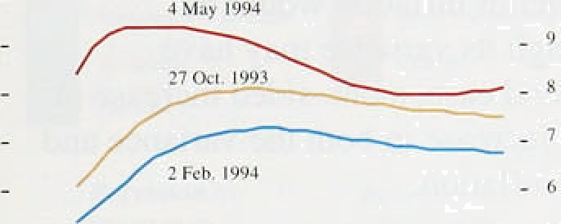

- 4



**Chart 2.6**

**Real forward rates**

- 4.0

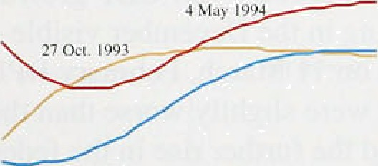

- 3.0

- 2.0



**fhart 2.7**

**Inflafion term structure**



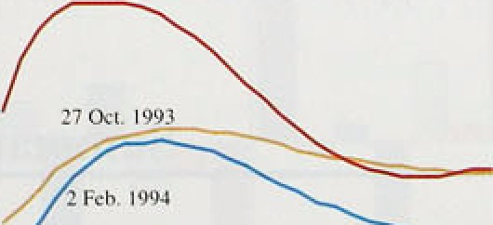





equity market—by 4 May. the FT-SE 100 index was down 12.19r from its peak on 2 February. The exchange rate has also weakened some 2.9% in effective terms over the same period (Table 2.C),

*Ratiunale*

###### There are three possible explanations for a rise in nominal yields:

a rise in inflation expectations;

a rise in the real rate of interest; and

###### a rise in the risk premium (reflecting increased uncertainty over real yields and/or future inflation).

By comparing data on index-linked and conventional bonds, the rise in implied UK forward rates can be split into real and nominal components (see Charts 2.5, 2.6 and 2.7).

Over the period since 2 February, the inflation term structure has shifted up across the full maturity range and most sharply at the shorter end. By 4 May, inflation expectations were up well over two percentage points to over 6% four years out. Expected real interest rates also showed an across-the-board increase over the three months. Again, this was most pronounced at the shorter maturities—expected real rates two years out had risen by more than a full percentage point by 4 May.

However, technical factors may complicate the interpretation of data derived .from the short end of the yield curve.

###### Any increase in the inflation risk premium (reflecting greater uncertainty about future inflation) or the real interest rate risk premium (=n=ting greater uncertainty about future real interest rates) will be embedded in movements in the inflation term structure and implied forward real interest rate curve respectively. However,

.one can gain some insight into likely developments in

.risk premia by looking at .the market’s expectation of futiire.bond market volatility, as implied by the prices of options on long gilt futures.

By 4 May, **.expected bond** market **volatility** had reached a level tliat was **nearly** double that **seen** in the autumn and

xml onRe Ma 1944

L”hart 2.H

£’K inzpliecl **h‹›iid market voIatiIity‹•›**

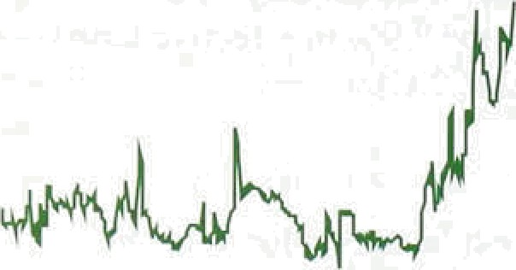

- - 4



**thart 2.0**

£'X **ten-1'ear go›'ernn ent Ijnnd yield,** 1994‹•›





7 14 21 28 4 11 18. D 4 l I l8 D 31 8° 15 22 29.''

Jan usiy 'F•nbTjary lash Aptil'

###### higher.than at any time during **1993.** This suggests that part of the rise in forward interest rates may indeed have been the result of 8reater uncertainty, though this cannot be split into its real and nominal components. But the observed increase in volatility could be the result of one

of two types of change in the risk premium: a mean- preserving, or a non-mean-preserving, increase in uncertainty. In the former, the risks of either higher or lower.inflation have increased equally. If this is the case, the expected level of inflation would be unchanged, even though. its variance may have increased. In the second case, a one-sided increase in risk would lead to an increase in both the variance and the level of expected inflation.

There are several reasons to suppose that both inflation expectations and inflation risk have increased. This interpretation is consistent with changing political risk and with market reaction to the cut in UK official interest rates on .8 February: the substantial rise in nominal bond yields some days after this cut suggested revised perceptions of the authorities' commitment to monetary.stability (see Chart 2.9). Subsequent news appeared to have an asymmetric effect on asset prices. For example, the upw.ard revision to Q4 GDP growth on! 22 February, the worsening in the December visible trade balance announced on 11 March, February,RPI figures on 23 March that were slightly worse than the market’s expectations and the.further rise in.the federal funds rate on 18 April were all:followed by sharp rises in ten-year bond yields. Conversely, the favourable RPI figures released on 15. April met with.a muted response in the bond market.

The rise in real interest rates in the short term may reflect a market expectañon of tighter monetary policy

in response to a perceived inflation threat, It is harder to. explain the rise in !long-term real rates (of around a half of a percentage point ten years out), since.!it .is difficult

to identify what might have ehangéii expectations. aboutl tlie .future.demand for„and supply of, investment in the world capital market.



2.3

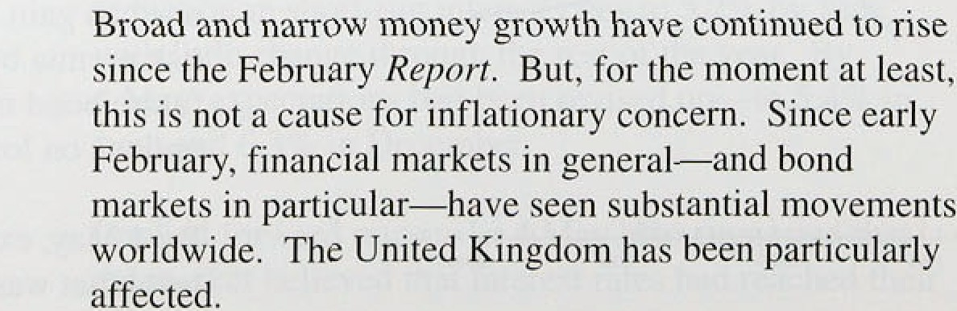

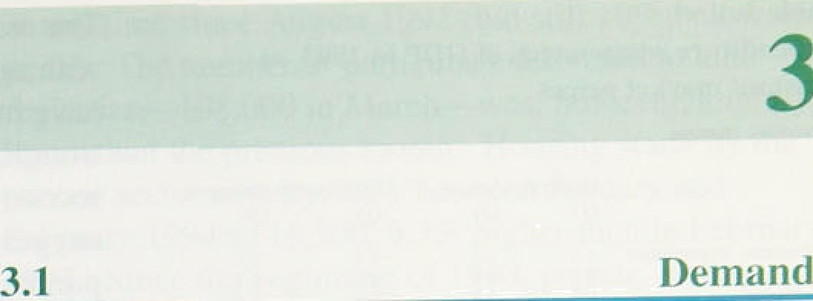

Chart 3.1

GDP



Cecassioii tsi







f97S QRW Q2.



.Non-oil **GDP** rose by 0.6% in the first quarter of 1994 when it was 2& higher than a year earlier, according to the provisional data. The pace of recovery has been comparable with that In 1981—82, but less than in 197fi—77. Non-oil GDP rose 3.39c in the first eight

quarters of this recovery, a little less than in the first eight quarters of the .l981—82 recovery. But the recent recession was shallower than that in 1979—81 (see

Chart 3.1). Total final expenditure in 1993 Q4 was 2.2% higher than a year earlier. On the expenditure side, the main contributions to growth over the year to 1993 Q4 came from consumption (up 2.3&o), stockbuilding (up l.4&n) and investment (up 0.3%) (see Table 3.A). The contribution of net trade was negative (- l.29c), as the rate of growth of exports declined and that of imports rose—although the trade figures remain unreliable and are likely to be revised. This pattern of contributions to growth in the latest available quarter is broadly representative of the whole recovery to date (Chart 3.1). Compared with the two previous recoveries, consumption growth has been more important this time—it has contributed more than l009c of total growth, compared with about two thirds in the early 1980s and a negative contribution in the mid- 1970s.

This reflects the large fall in consumption during the recent recession.

###### ^: ^’*,* Shree›’.‹r»tn/secf‹w-

Consumers’ real expenditure rose by l.19r in 1993 Q4, the.seventh successive quarterly increase. As a result, consumption was 3.2% higher than a year earlier; real personal disposable income grew by only 0.6&r over the same period. The saving ratio has now declined :by

2.6 percentage points from its 1992 Q3 peak.

Movements in the saving ratio have, however, been less

##### .pronounced during this cycle than in the recovery of the

:ear1y 1980s. At.the GDP trough in 1992 Q1, the saying rntio,was 11,5d, and it has since declined to 10.2%.

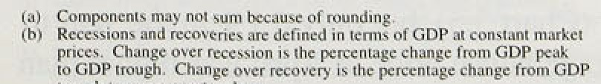Over ltte same number of quarters in the previous re:covery, the saving ratio fell from 14.1% (1981 Q1) to 10.1 (1982 Q4).



*1* nfiaiioii Rcppri: Ma; y_1094

nents ot £;DP in 1993. at



ri›nslani market prices



|  |  |  |  |  |
| --- | --- | --- | --- | --- |
| Consumers’ cspcndauru | 1.2 | l.l | 2.7 | 3.2 |
| Puhlic ccnsun\ptinn | 0.2 | -0.4 | 0.8 | -‹i. |
| D‹›n›esiic Jcn snd | IJ 1 | I.g | 1.¿ | 3.3 |
| Espr›n, | 2.5 | -2.0 | 5.0 | I.n |
| I iiipons | 1.7 | 3.9 | 2.9 | 4.7 |
| €iDP at marries pricvs | 0.b | o:6 | 2.1 | 2.4 |

t”hart .1.2

L”‹›nsut›tcr cnnfidencu **and totat retail sat€'6**









199 1 92 93 9'l



Rutio of debt to income: corporalei•' and

The recovery in consumer spending has been associated with rapid growth in purchases, of durable goods, which have increased by over 189» in .real terms since the trough, almost reversing their decline during the recession. The strength of spending on durables might suggest that consumers are willing to make large purchases and are relatively unworried by the increases in taxes. But part of the inerreease in durables spending represents a release of demand that had been postponed during the recession.. Spending on non-durable goods has, by contrast, been relatively subdued; it has increased only 4.5% in real terms from its trough at the beginning of .1992. And spending on services has been still more sluggish, rising only 3.39 between 1991 Q3 and 1993 Q4.

How fast consumer spending grows over the next few months depends largely Ion the reaction of the personal sector to the tax increases whlch will occur over the next two years. These were announced several months before taking effect, whichlmakes the response of the personal sector now particularly difficult to predict. In the past, large personal sector.tax increases have been associated with relatively slow subsequent growth in consumption and incomes. The rise in taxes on the personal sector will amount to about 4% of personal disposable income by fiscal year 1995/56. This

compares with a rise of about 3% over 1974/75-1975/76 (unadjusted for indexation) and just over 2% in l98l/82—1982/83. Thelavailable ev{dence suggests little reduction in consumers' expenditure so far; retail sales volumes rose by l. I % ii: the



e II

' ' ‘_' „ firs‘f‘ upon u‘e ene , ee

h f

j bent eor ‘ “







"‘”'

I9y6 y8 s0 87 84 86 88° 90 'S2

seasonal factors (Chart 3.2). Other.factors suggest a

, continuing recovery in consumption. Since 1991, individuals haVe been more willing than companies to take on new.borrowing. The ratio of debt to, personal sector income has fâllen slightly from its,peak (Chart.3.3) while the::flow of new debt has risen recently. In .19.94 Q1, bañks: and bui1d!ing so:'pieties leint

£5.9 billion.to .persons,.the1highest flow of:gross..lending

###### ' for over a year.but,.compared with persona1 ‹disposable

income, personal sector borrowing has been well below

* + 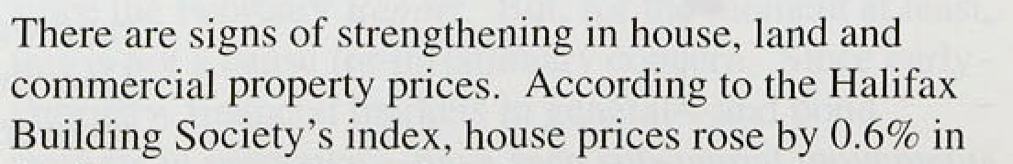tire histories



’4).

the first quarter (Ciiari 3.â),.but only, 0.1& in the.year t.o April.. The averageihouse price in Aptil was iiiyher tiian .



Chart.4.4.

Ratio of the.’flow of debt to.income: corgorate‹•› ’and. personRI\^t sectors





— .- •Q







Chart 3A

flouting market activity





- 2

1:10 .



'Chart 3.6

Interest jiayment ratio‹< and house price to





at any time since August 1992 (but still 10% below its peak). The number of particulars delivered to land registries—108,000 in March—WhS, however, slightly lower than the previous month. Housing starts by the private sector rose by 7.8D between January and February 1994 to 16,500, 9.3&» higher than in February 1993. Since the beginning of 1993, private sector housin:g starts have fluctuated quite widely around a mean of 15,400 per month, which is 1,900 higher than

###### their average level between 1990 and 1993.

House prices are at relatively low levels by most measures. The house price to earnings ratio is at its lowest for over a decade. The .regional variation in house price to earnings ratios has lessened. Chart 3.6 shows lthat at present it takes about 30% of average earnings to service the average mortgage in Great Britain. This measure was first available in 1967; measured by it, house prices in London and the South East are more affordable than ever, and—for the first time-than houses in the rest of the country. All regions

have experienced a marked improvement in 'affordability’ since 1988—90. This will be offset to some extent by the restriction of mortgage interest tax relief,.first to 20% and them .to 15% ill April 1995. For the average household with a £46,000 mortgage, the first

.increase will raise housing expenses by £173 a year. In addition, negative equity remains a significant burden on the sector; the Bank’s estimates suggest that in 1994 Ql there were still 1.3 million households with negative equity totalling £7.6 billion.

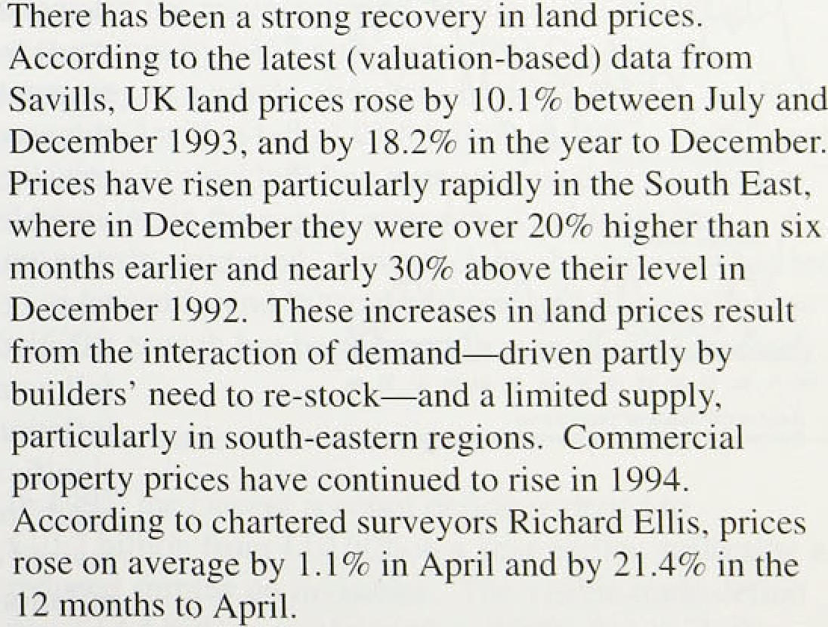

*The corporate sector*

###### Jtrpqgâr in?estment’1ias played.a small part in the groWth ef GDP sci fat’.in!this recovery (Chart 3.1 .above).

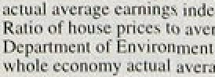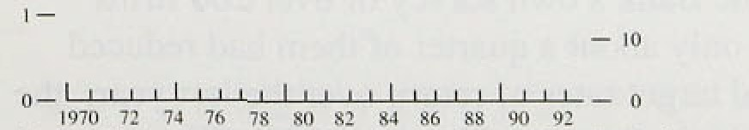

lnfl'ation Rcppri: Mnv 1094

Companies have.been slow to increase.their!investment, as they continue to adjust to the high debt levels they took on in the late 1980s (Charts 3.3 and 3.4)

corporate debt has been reduced. Investment did, however, begin to increase in the second half .of last year; by 1993 Q4, non-residential fixed investment was at its strongest for 3'Ji years and 2.2% higher than in the same quarter of 1992. In the non-manufacturing sector, it rose by 1.8%.

Chart ñ.7

Factors limiting capital cxpcnditure‹•

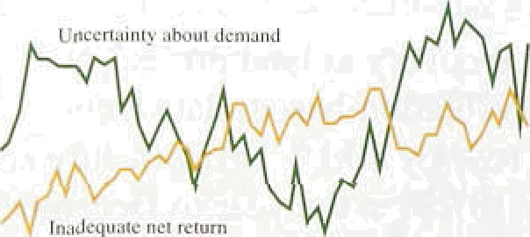



— — 4{}

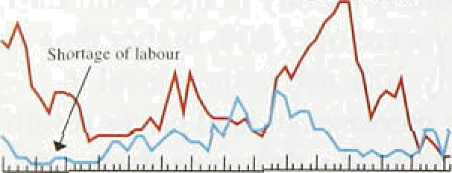





Investment has not .risen by as much in this recovery as it did in 1982—84 (Chart 3.1), but the share of investment in **GDP** has remained two percentage points higher on average at over 20%. This reflects the rise of the investment-output ratio in the services sector through the 1980s. Investment in plant and machinery has increased most, suggesting a greater emphasis on increasing productive capacity. Investment in plant and machinery was 34.89 of fixed investment in 1993, compared with 30.7% in 1982; and in 1993 Q4, it was 3.79c higher than a year earlier, compared with a ldc fall in investment in dwellings and other new buildings. This pattern of investment is common to both manufacturing and services, but for services the rise in investment .in

plant and machinery has again ñeen particularly marked.

The slow recovery in investment comes at a time when, according to the CBI Industrial Trends Survey, the major factors limiting capital expenditure are uncertainty about demand and an inadequate rate of .return (Chart 3.7).

Indeed, the balance of firms citing uncertainty about demand as a factor limiting investment rose to 55&a.in April from 44% in January. The proportion of respondents citing inadequate returns has .been .higher in this recovery—currently 44domand may reflect a transitional problem in the move to lower and less variable inflation. Those .firms who assess investment decisions on the basis of a required rate of return will stake account.of the expected rate of inflation in calculating the nom!inal. return they require. But following a 20-year period in which the average inflation rate has been close to l0,&o, adjustment to a significantly lower rate may not be i.mmgdiate. .As a result, required rates of retum!may.!not yet:liave been revised down.sufiicfently to...reflect lower (expected) inflation. The Barik'.s.o,wn survey, of oVér 20.0,firms.!



:showed that only about a.quartér o( them had.reduced their.nominal target.rñtes ,of retiirn oder the last ydar, :the average required rate was **still** around 20&o.. **Tllé** survey, also:showed' that a'substantial minority ofcompanies usqd pay-back periods, rétber than a raté of return,:as

Ch Brf 3.8

Return ‹in «apittil‹•

their main investment criterion: lower inflation c‹iuld reduce investment levels using thi.s criterion. since when inflation falls the period required for the nominal outlay

* + - to be returned will lengthen.

“" '“' ' Firms’ concerns about inadequate returns seem

somewhat at odds with the latest data on profitability and the cost of capital. The average pre-tax net rate of return

' on capital for industrial and commercial companies (ICCs)—excluding those in North Sea oil and gas

extraction—was S.4Vo In l9°93 IChart 3.S).



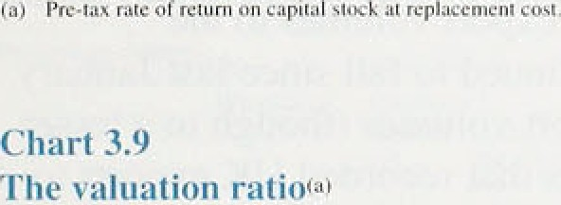

1.2





fihnrt 3. III

**ftetaincd earnings'*› and in›’ustn1cnt**



— — 12



— — 6

— — 2

198081 82 83 84 85 86 87 88 89 90 91 92 93



Two other factors suggest the investment outlook is favourable. First, the valuation ratio of ICCs—whch shows the ratio of their financial valuation to the replacement cost of their fixed assets and stocks—has risen during the recovery to 1.2 in 1993, compared with a value of one in 1992 (Chart 3.9). A ratio in excess of

one provides an incentive to raise funds to invest in fixed assets. Second, the financial position of the corporate sector is strong—ICCs’ retained earnings have grown by over a third in 1993 (Chart 3.10). They have continued to make net repayments to banks: ICCs repaid

£11 .9 billion in 1993. compared with f2.4 billion in 1992. And they have increasingly turned to the capital markets as a source of external finance—net capital issues totalled £14.9 billion in 1993, compared with

£8.3 billion in 1992. These financial transactions have led ICCs to have a financial surplus of £3 billion in 1993. compared with a deficit of £7.2 billion in 1992.

Stocks in the manufacturing, wholesaling and retail sectors rose by £457 million in 1993 Q4. For the economy as a whole, they rose by £462 million in 1993. compared with a fall of fi1.8 billion in 1992. Significant revisions to stockbuilding data suggest that the level of destocking in the recent recession was higher than previously estimated. Nevertheless, the recovery has led to an upward trend in stockbuilding and its contribution to GDP growth has been larger than in the last recovery.

In 1993. the current account deficit widened to

£10.7 billion from £10 billion a year earlier, reflecting a reduced surplus on invisibles. The visible trade deficit was £13.4 billion, unchanged on 1992; but excluding oil and erratic items, it increased from fi l 6.1 billion to

£17.6 billion. The visible deficit with the rest of the European Union widened, while that with other countries narrowed.

25

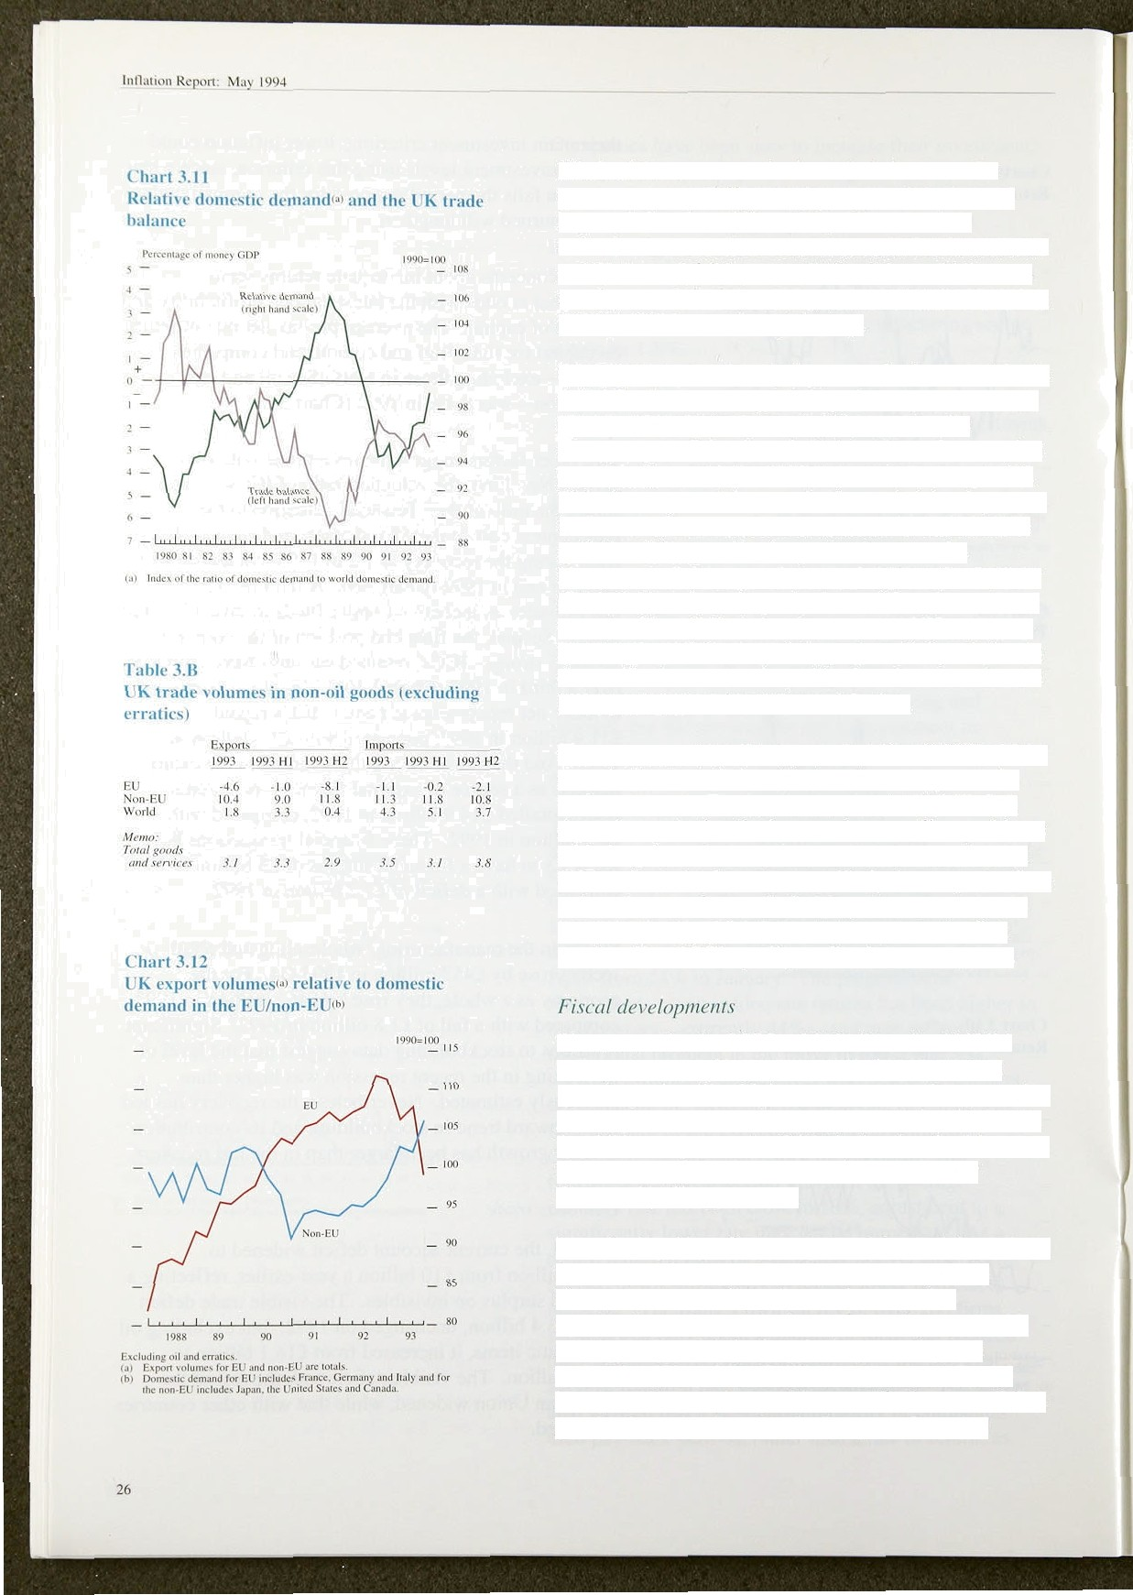Much of the movement in the trade balance can be explained by the different rates of growth in demand here and elsewhere (Chart 3.1 I). The sustained reduction in the deficit between 1988 and 199 l occurred as UK demand fell by around I % while world demand rose by over 8 . Since 1991, the deficit has widened as relative UK demand has picked up.

Over the last year, the slight increase in the non-oil trade deficit has been accompanied by slower growth of both export and import volumes (within imports, the strongest growth has been in finished manufactures, but particularly in capital—rather than consumer—goods). This slower growth is a result of recorded developments in EU trade, but uncertainties continue to surround the statistics. The growth of export volumes to the European Union has continued to fall since last January (Table 3.B), as have import volumes (though to a lesser exlent). Chart 3.12 shows that recorded UK exports to the European Union have fallen substantially relative to demand in those countries, while for other countries the UK’s performance has improved further.

These movements call into question the reliability of the recorded trade statistics. Trade volumes appear to be underestimated. The implication for the trade deficit depends on whether the lower volumes reflect problems with the price-volume split or with the lower recorded values. Import values are more likely than export values to have been understated. In May, the position should become clearer, as the data will incorporate the first results of the CSO’s quality audit of the new system.

The outturn for the PSBR of £46 billion for 1993/94 reflected a lower-than-expected rise in government spending rather than higher tax revenues. It appears that government departments have spent less than budgeted. In addition. repayments of debt by local authorities were higher than expected, as a consequence of lower Community Charge arrears.

How fiscal policy affects output and demand depends on the composltion, as well as the level, of spending.

Government expenditure has made a negative contribution to growth in the recovery, compared with small positive contributions in the preceding two recoveries (Chart 3.1). Publlc sector non-residential investment has made a positive contribution overall, but provided no stimulus over the last year. If capital



Table 3.C

**Output components of** GDP **at 1990 factor** cost



Weighis ta; Quarterly Four•quarter



###### spending increases the productive capacity of the

:economy, then raising.the proportion of capital expenditure will also lead to a lower debt-to-GDP ratio over the medium term. In the November Budget, the Government announced that the public sector should borrow no more than required to finance its net capital spending when the economy is back on its long-run

growth path. (Net capital spending is projected to be

###### around 1'/ 9» of GDP in each year until 1998/99,

compared with 2'/ ha in 1993/94.)

3 2 u

Non-ofl GDP fell by 3.99r from peak to trough in the last recession and has since risen by 3.39c. This increase means that non-oil **GDP** is now growing at or slightly above its underlying trend. Total GDP rose by 0.79c in the first quarter of 1994 (to 2.69c above its level in

1993 Q1), as it did in the previous quarter (according to the output measure). The growth of oil and gas output

C ammho« Qed»a4‹m’

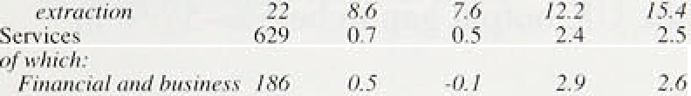

*Disinñuifion,* /zorrfs,

.' 2 -0.4 0.9 -1.9. 0.1

28.1 t. I l. 1 2.6 3. I

remains particularly strong, and the construction sector weak (reflecting the greater cyclicality of this industry); apart from these, the recovery of output has been broadly based across industries (Table 3.C). Industrial

production fell by 8.4% from peak to trough and has

since risen by 6.9%.

*fiaieri'n$.* /42 /.J *0.8 3.7 4. I Tfianfipori,* storage.

|  |  |  |  |  |  |
| --- | --- | --- | --- | --- | --- |
| *coi*tr *finnnicai,'ie i’i* | *..84* | *l•9.* | *I.2* | *.3.6.* | *4.3.* |
| GDP . | 1,000 | 0.8 | 0.7 | '2.1 | 2.4 |
| Non il | 983 | 0:6 | 0.5 | I.8' | 2.1 |

(o) 199}uMghsjnGDP,ouiOflOO0.



Statistical measures of GDP growth may be biased downwards. Recent work at the CSO found that initial estimates of CiDP growth tend, on average, to be lower than the final estimates. Upward revisions to current- price GDP on the expenditure measure (between the first and the twelth official quarterly estimates) averaged 0.9% between 1980 and 1989. The size of the revision was larger in recovery periods (l.l & ) than in recessions (0.6%). The revisions were highest during the expansion

of the late 1980s, and significant improvements appear to have been made in data collection since 1989; but current data might:still understate the rate of growth. In addition„the recent statistical problems with the trade data mean that the use .of export prices to construct the estimate of manufacturing output is likely to lead to its understatement by around loo, biasing downwards any *gro*wth rates measured across January 1993.

Any estimate of the gap between actual and potential putput is imprecise because of the difficulties of measuring potential. One simple approach is to define potential output as the output which could be produced if





all the available labour and capital inputs were efficiently utilised. This shows how.much additional output could be produced if unemployment were at its natural long-nin rate and capital were operated at the normal utilisation rate. Some assumption must also be made about the.rate of technical progress.

The average annual growth of GDP between 1957 and

199 years at similar positions in the business cycle— was 2’/ %. Over the same period, the recorded gross capital stock grew by just over 30r .a year and the labour force by '/2% a year. Taking these figures at face value, and using a simple ‘production function' approach, gives an annual rate of technical progress .of about I ' 4 O.

From 1990 to 1993, the labour force contracted by a little over '/4% a year and capital accumulation slowed to 2'/ % a year. Assuming unchanged technical progress, this suggests a growth .rate of potential output of 1'/›9r and consequently an output gap .of around 6&• now (if it was zero in mid-1990). But this ignores the tendency for capital-scrapping to be higher in recessions and for the skills of the unemployed to deteriorate. Hence the output gap is probably less than 69c. The OECD and IMF estimated the UK output gap to be 5%-5'/i% in 1993.

## 3 3 S a

The growth rate of output has probably risen slightly above trend. Output growth is higher for both goods and services. Over the short term, consumption growth is: likely to weaken, as consumers respond to the latest tax increases; but investment may strengthen as the persistence of recovery becomes clearer to firms. The output gap is narrowing, but limits in capacity are still some way from constraining producers. The net trade position remains clouded by statistical problems.



Chart 4:1

‘Underlying’ earnings.growthi•i



— — 4



i’99 9’2’ 93’. 9.4



Table 4.A

Labour market **indicators**

Unkind. Kingdoni..seosonnffJ odjwied





|  |  |  |  |  |
| --- | --- | --- | --- | --- |
| 'Ch8nge (toojo).‹a› 000's | Maz.' 94 | -30..3 | - 19.5. | -23,.3 |
| :Aae”’’’”’”’” "’ %’ | ”’” | ’’9.7 | (0.’’3’ | 10.4. |





4.1

Earnin s

Nominal earnings are rising more rapidly than last year. The 12-month increase in underlying average earnings rose from 39c in November to 3’/•% in December and

3'/•% in January and February (see Chart 4.1 and Table 4.A), with similar patterns in manufacturing and

services. The underlying figures only gradually reflect any pick-up in actual earnings because they are

.calculated using a three-month moving average. The

.increase in actual earnings rose to 3.1% in December, 3.6& in January and 4.4% in February. But the current divergence between actual and underlying earnings is mainly the result of .large bonus payments in bariking, finance and insurance, which are excluded from the underlying series.

Wage settlements have also risen since the February *Report* (Chart 4.2 and Table 4.A). The median rate in the whole economy increased from 2.0% in December to 3.5% in each of the first three months of the year, according to Industrial Relations Services (IRS). In those months, there was .a relatively low proportion of public sector settlements, which depressed the measure last year. IRS report that the median value of the few public sector settlements since February has been 2.5%, the same as in the private sector. The CBI reported that settlements in manufacturing rose from 2.09o in December to 2.8& in January. In the services sector, however, settlements fell from 2.7% in 1993 Q4 to 2.1%



in lii94 Q1. As noted in previous *ReP*



increases in

vacancies 000's Mar. 94 tl39.8 :12?.3 J23:I



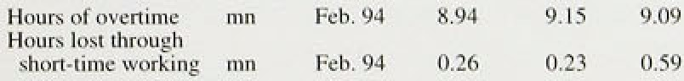



.Fe’:94„



settlements do not necessarily precede earnings increases:. may move first because of increases in overtime payments, for example, or in

performance-related pay.

noininal earnings accelerated, and will this contique:? The most important factors are the demand



-fpr and supply of labour, productivity growth and the priée expectations of those who set wages.



# .

# 4.2 Demand.for labour

in noriiinal eâmings..is.that, for algiven labour supply, labour: deinand hasancreased. Tfiere is some evidence this is



P

s



Chart 4.2

**Private and publir sector settlements**





d“uhle 4.B

Changes in employment



WinT«r Spring Summer Autumn



 -S9 -48'





Selr-employed

Fuli-linie 

|  |  |  |  |  |
| --- | --- | --- | --- | --- |
|  | - I S | 30 | I4 | 2. |
| r«ii.time | -82 | -26 | -40 | -9 |
| Part-lime | I2 | !y | 14 | 26 |
| Full-time | S | -4 | - IR | -39 |

happening, butlthe increase is small.

,Seasonally-adjusted manufacturing employment increased by. 8;000 {or abo:it 0:2 ,) over the. first two. months of this. year, but is stilt lower than a year a . Data on employment in the economy as a whole are less timely. According to .the Labour Force Survey„ employment increased by 74,000 between the summer

.and autumn of 1993 (Table 4.B). Most of the increase was in part-time employment (predominantly of women). This picture .is broadly the same as that suggested in employer surveys. Recent revisions to employment figures based on employers’ returns suggest that the level of labour demand was higher.at the .end of last year than previously thought, but it had not increased.as much since the trough of the .recession

.as the previous data indicated. The new data show an! increase of 111,000 and a fall of 6,000 in the thi!rd and fourth 9ll °" er s of 1993. respectively. Data on hours worked also point to .relatively stable labour demand.

.hideed, the Labour Force Survey shows that, by last autumn, .hours worked .per week were no greater than in autumn 1992. The relationship between!total hours worked a:nd em ment has changed; the importance of.part-time work has increased, so:that the total number of people employed was able to increase during 1993 without the demand for person-hours increasing significantly. This is:consistent with the evideqee that output has been growing at much the same rate as trend labour



Changes ›n u'orkton:e in employmenc

Totnl hours worged per



-143 92 -24 74

 -86

Turning to indirect indica.t0ors of laboqr demand, vacancies in tlie:economy as a.whole rose to 139,800 in March up..13.:5.S'»: over.the year nd hours lost through short-,time working in.manufacturing more.than

But



weeL (millions› 782 819 789 828

NB I Total in boJd may dJlTcr because figures for fUII/yen-lime split do:rat incl«dz



iriost of these changes.had takgn.placg by tire autumn .of

last year. Increases. in laboiir deriuind.alone are probably

.i.iisufficient to explain the.accelerati.on of nominal. earnings.



Demcmb‹r. T!e’LhSquiñemz Dwm.,xñLI/RfofWinwnJk.





# n4o3d

tie o n

e s f

The most commonly,used.nieasure. of the.excess supply of labour is..the number of people.claiiñing un'employinent,benefit. The fall iir claimant unemployment resumed in Febru , after a rise in Januâry (an:ano.maly reflecting the.timing of the..counts in December and January); iinemployinent fell again iir Mñrch to 9.7& ‹if the workforce (2.72 rriillior),

**,compare‹i** wlti ’10.ñ a’ y1’’m ’etidinr iS.93, million;)„

**Unemployment** is falling aero.ssall regions



**Chart!4:3** .(see Chan 4.3). .Compared with the same stage of the

Regional unemployment rates in Great Britain t•l.' 1982 84 recovery, it is now lower in all regions except ’." d ?‘ "“' . .the East Midlands and the South, Unemployment began **S4*th: incl** sSeujh:Hi.SouihW **t.and** kxy **Angliu tO** full earlier in the recovery than in the early 1980s

': Fionh:..include...f›terth, Nprili W.*si oa4 Y.or1uitirc:,and Hurnbc'rsidc

(see Chart 4.4). This was partly because firms shed

##### ” - • workers sooner in the 1990s recession and took on new



ta) Weighted by wod‹iomc in cach region.

Chart 4.4 Unemployment rate





— I4



— 4



workers sooner when the recovery *came.*

Tairle 4.C shows that since the winter of 1992—93 there

.have been similar reductions in numbers seeking work (the LFS definition) and claimant unemployment (the more familiar count). At the same time, more people

who do not claim unemployment benefit are seeking work and fewer people of working age are completely outside the labour force. Table 4.D shows that unemployment fell by 45,000 between summer and autumn last year. The percentage drop was highest in two groups: those aged l6›-24 and men.

Looking at the overall imbalance between the demand for and supply of labour as a whole is insufficient to judge the downward pressure on earnings exerted by the unemployed. The regional match, for instance. between surplus workers (the unemployed) and surplus jobs (vacancies) is also relevant. When it is costly to move between regions to find work, having workers in one place and jobs in another generates more upward pressure on aggregate wages .than otherwise, as firms

in the. regions with shortages bid up wages to fill vacancies, and many workers in regions with high unemployment enter long-term unemployment and lose their marketability. Regional mismatch is much less now than in the previous recovery. Thus any given level of aggregate unemployment should be associated with greater downward pressure on earnings than previously.

Table 4.C

**:Alterriati:ve»nñasiices of the.change.in**

**un»aiployñtent** .



,Txd’’’ !’’-:74 ’”46’ ’-OD' ’’’’106. . -9 -&



Taken together, the evidence on unemployment suggests that excess labour supply has .fallen. This does not contradict the patchy data on labour demand.. First, the number of unemployed can fall with no increase in labour demand if part-time work becomes more prevaJent; it has. Second, the unemployment data are more fimely than those on labour demand, and it is quite possible.that.employment has increased this year; it has in manufacturing. Third, in the medium term, falling labour .force participation rates amongst 16—24 year-olds (as a Result of increased participation in full-time education and training), and 55—64 year-olds (as a result of early retirement), will reduce the overall supply of laboiir.

31





nent





Winter Spñng Summer Aut\tmn

-61 -6 -42

27 -11 32 -3

It is likely that the drop in unemployment has changed the climate of wage bargaining, leading employees to feel more secure and to seek higher real wages.

Employers and employees may!.also be more, con(ident that labour demand will increase in the future, and bargain accordingly. This could account for some of the



A B

Total



18 -j 3 34 -43

35 -19 -13 -1



?7 -13 -3(1 15

-3 5 -10 7

92 -71 l6 -45

.recent acceleration of nominal earnings (assuming unchanged .inflation .expectations). But, historically, the sensitivity of wages to unemployment has been rather low in the United Kingdom.



t”h«rt 4.?

\\'hnIv ccr›n‹›i» **pr‹›d’ucti1'ity** and **unit** wage costs



— — 4.

- 2





Chan fi.s

Whole economy' real product wages in relafion to produetivity'•'

# 4 o uct t

In the economy as a whole, the rate of growth of output per head has fallen since early 1993 (Chart 4.5). The growth rate of output per person-hour can be calculated for manufacturing, and it has also fallen. The.most likely explanation for the slower rate of productivity growth is that firms now synchronise their output and employment levels more closely, which means that the rates of growth in productivity associated with the recovery will not be as rapid this time.

###### The slowdown in productivity growth has had an effect

.on unit labour costs in manufacturing; they rose by 2.2% in the year to Febmary 1994, whereas in the year to February 1993 they fell by l.2&•.

Improvements fn labour productivity relative to the real product wage paid by employers (ie reductions in real unit labour costs) increase profitability and are likely to increase the demand for labour. Chart 4.6 shows that, since the beginning of 1992, the real product wage has fallen .sharply relative to productivity. So despite the recent productivity slowdown, it is possible that there will be increased upward pressure on real wages—first, because labour demand will increase and, second, because the high levels of profitability allowed by the current level of real wages may strengthen employees,' bargaining power.

e o

##### Price expectations.’are..!important.i.n translating! planned/ q real wages into aoininal *ierms:* :Monetary!po1icy will

*not* validate i.nf1ation.outside the target.range. I(,

in nevertheless, higher inflation’ is assumed in pay "

##### qegotiations,, real wage.lévels will turn out to be too



And.unemp1oy:oieot higher,tha:n: it need be.

##### .survey:of.inflation expectations..suggests that,





Chart 4.7

**RPt inflation** vs employees’ expectations

EinpIOJ'e<s''ezpeciaiions t l 'tear'forctpsi}

199 i . 92 93 94 95



employees' expectations have been very slow to adjust to changes in inflation (see Chan 4.7), and remain above actual .inflation. Other indicators of inflation expectations also suggest that there is scope for downward revision in expectations in response to past forecast errors. Such a revision would tend to reduce nominal earnings increases, so working in the opposite direction to the productivity effect discussed above. So far, however, employees’ expectations of inflation have

* changed little in recent months.
* 4 6 Th e i ib i e el o e o e t
* What levels of unemployment and real wages are consistent with stable inflation and monetary growth in

###### the long run? Several factors are influential:

1. the power of employees is important. Measures of employee power have declined in recent years: union membership has fallen from 13.2 million in 1979 to 9.6 million in 1991 , with the proportion of employees who are members declining from 57% to 439 ;

**Chart 4.8**

**Regional variation** of earnings‹•›

1. government measures may have improved the efficiency of unemployed people in looking for jobs and the skills of the long-term unemployed; long-term unemployment peaked at a lower level in the recent recession than in the mid-1980s (partly because more people passed through government

q, schemes);

1. research suggests that employees can win real wages above market-clearing levels only where employers have some monopoly power in their product markets. World trade growth and the increasing integration of the European economies have opened up more sectors to competition. lmplementation of the agreement on the Uruguay GATT Round will increase competition further;

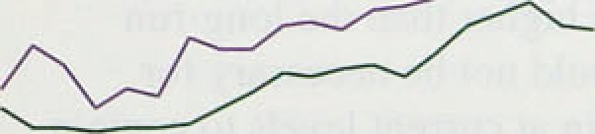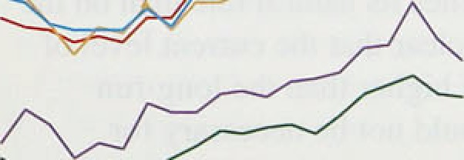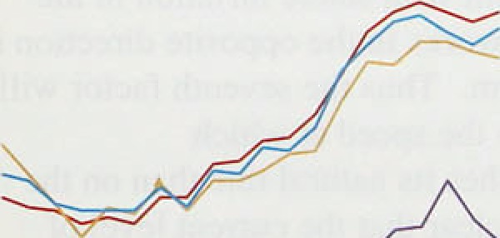

’'j’904’ 76:' ’!7 ’ 80'. ’82 M



(all'' Cbiffmcñu of eñen:

- 0:0



(iv,) wage.bargaining became more decentralised in the 1980s: the Workforce Industrial Relations Surveys show that, between 1980 and 1990, there was a fall

.fn the proportion of collective bargains covering multiple employers and an increase in the proportion of.non-collective pay settlements set at establishment level. At the regional level, these changes have been associated with an increase in the.:variation of earnings (Chart 4.8). In principle, this should assist wage flexibility in response to

3.3

lnf1.itiuI\ kcpurt: tVt‹ty l99J _ _ _ _

local economic conditions and lower the rate of unemployment;

(v) the structure of benefits determines what

proportion of their previous employment income the unemployed receive. That proportion has fallen over recent years:

t,;) self-employment has increased in importance (from 6.9% of the economically-active population in 1979 to 11.4% in 1993) and, on average,

self-employment incomes are more sensitive to the cycle than are employees’ wages; and

(A) periods of .high unemployment can raise the rate of unemployment consistent with price stability. If the unemployed’s ability to compete in the labour market declines with .the length of unemployment (for example as old skills decay and new ones are not learned), and if the unemployed are slow to lower the minimum wages they will accept in line with their reduced productivity, the economy will need higher levels of unemployment to contain

.nominal wage demands. Furthermore, if.the capital

.stock is slow to rise when demand recovers .and if the existing capital stock incorporates fairly fixed capital-labour ratios, price pressures may emerge in the goods market before unemployment falls to its equilibrium rate. Such arguments may explain the fact that after each peak in. recent!recessions unemployment has! never fallen to. its previous .low.

The first six of these factors should all lower the level of unemployment consistent with stable inflation in the long run. The seventh works in the opposite direction in the short to medium term. Thus the seventh factor will have more influence on the speed,at which unemployment approaches .its..natural rate than on the natural rate itself. .It is.clear that the current level. of. unemployment is much higher tfian the long-run equilibrium rate. It should not be necessary for unemployment to.remain at current levels to contain inflation.

.4.7 . , **’Outliiok**

The upturn.in.nominal:gawnings growth does not mean

that the elconomy has.already reached‘its long-run

.eq.ui1!ibriurn unemployment rate. Mmost all the:receht. structural’ changes in the labour...market. mean. that the! long-run.‘equilibrium.unemployment te should:now.be

3.é



lower than in the 1980s, though the loss of skills associated with unemployment will hold it up in the short run. Past inflation projections had built in some increase in nominal earnings growth, and some recovery in reaJ earnings was to be expected following a fall (relative to productivity) during the recession, although the increases are a little larger at this stage than expected. The increases will nevertheJess become a source of concern if they lead to an upward revision of inflation expectations on the part of employers and empJoyees, or if rhey reflect upward shocks to real wages unrelated to increases in labour demand. It is puzzling that earnings Should be increasing as fast as they are al fhis stage in the recovery. and it will be necessary to monitor labour market developments extremely carefully over the next few months.

35.

 



— — 1 4

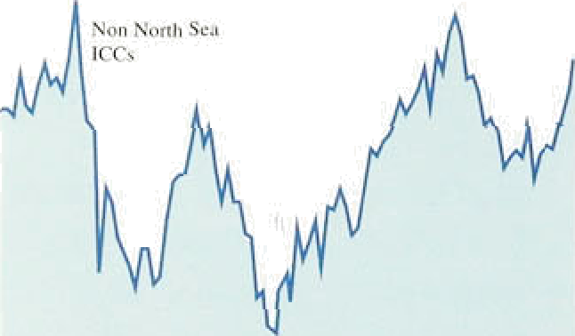



*fl* ***lilnuf”i cturets’* ‹›utput** prices **and input** cests

‹excluding f‹›L›‹I, drink **and tol›accu)**



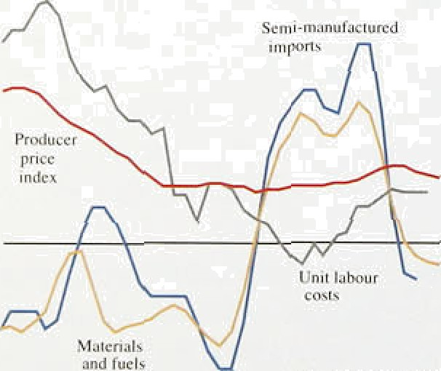

_

_ ,

4.

## UP o b I t

Profitability has continued to increase. The rise.in profitability reflects higher prices relative to average costs, and increasing capacity usage. Cost increases remain subdued.

The trough in profitability reached in 1992 was at a much higher level than in either.of the two previous recessions. Since then, profits have increased at a rate broadly similar to those seen in previous recoveries. As a result, the pre-tax rate of profitability is twire .as high as at a similar point in the l9B2—84 recovery. In

1993 Q4, the rate of return on the capital stock (valued at replacement cost) was 9.5*%,* only 1.2 percentage points lower than its peak in 1988 Q4 (Chart 5.1). Indeed, the present rate has been exceeded in only four quarters since 1973. Several factors help explain .this profitability:

wider profit margins in the tradable goods sector,

###### following sterling’s exit from the ERM;

higheT capacity utilisation, as both domestic and export producers have increased.their volumes; and

a slow rate of growth in average unit cos!s, in part. because of slower input price growth, but helped also by steps firms have taken to:contain labour costs.

Chart 5.2 shows changes in manufacturers’ output prices and the costs of the manufacturing sector. Some of the latter are highly variable. One way of gauging their importance for inflation is by testing whether!shocks td the cost component liave!a continuing: impact.. Shocks to material and fuel costs and to unit labor costs.usually.! do persist. .O.f these, unitclabour costs are beginning.to show signs. of picking up, Material and fuel prices!have. rebounded somewhat ovér recent ñionihs, .but on.a

12-month comparison .continue to.fall.

Tañ!e 5.A shows how movements in input pncesl havé fed.theugh to manufâetunng ou@ut prices.! Weighted average costs increased fly only 0:4& i:n the year to Febñiary. Net domestic iaargi.me; however, are Estimated

36’:’



M e Auring input prices„ **unit prufits and** output pFiceS





0.8'



 O} -.0.9.. 7.8.



:Q4: 2.3 0.2

 'Jan: 2.3’ -0.4

Feb, 2.2, -4:7



2.7.

-2.0

3.6



5.2



-ft.8





"6/0





_^.9

3.2



4.+





4.7



2.S

2.6



2.0

2.0





0.4

10.3

I IT.3





1.3



6.5



7.3

J.0



1fJ. I



2:2

2.6

2’4

2/7



2.7

2.5



Chart S.3

**Manufacturers’ i-tp‹›i-tcd and expected price developments UB I lniluslrial Trends Surve;'l**









tz)' 'Balder o*f.finfis cxpcci'iog/re poning nse„s: in average pnces;.of:'d'oniesilc





Manufactu **re.re’ reprinted** and **expected** cost







:’lb) ” CB!.gucctIin 's;rckr to next focrmonitis and;pest focrmooihu

to have risen by 10.1%. Some rebound in margins was to be expected once the squeeze on domestic producers induced by the exchange rate depreciation dropped out of the year-on-year comparison, but the extent to which manufacturers’ net margins have contributed to output

.price inflation over the past four months has been considerable.

Charts 5.3 and 5.4 depict reported and expected cost and price developments, taken from CBI surveys of manufacturers. Costs have turned out broadly as manufacturers expected, but they have consistently been too optimistic about their selling prices. This has been true to some extent since the surveys began, but the feature was much more pronounced during the early 1980s and the 1990—93 period. Closer inspection of the survey shows that the gap between reported and expected prices is largely explained by more firms

.havi.ñ!g .to cut their prices than expected to do so. Such discounting might not be. picked up in the official price

.‹rata.

The picture .that emerges for the retail sector is very

;Jifferent. After removing the effect of duties and VAT, retailers.’ selling prices have risen much more slowly over the last two years than tlie prices they have had to pay for thei!r stock—the difference.was 4'/ percentage. points over the two years to 1994 Q1.

In its Distmñutive Trades Survey, the CBI asks retailers and wholesalers about reported and expected price movemehts.. Charts 5..5 And 5.ñ illustrate!.that ion the.past



e.ps onses:.hav,e.!not moved with the prices actually





Retailers have been consistently overoptirri:istic!in.thel prices they expected. o.ver.thd past.é.oupl.e.of!yeis; .this has ñeen less true of.wholesalers.



It is useful to look at pricing behaviour and developments in margins alongside ‹developments in capacity, The CBI’s sufvey asks rrianufaeturifig firms whether they think prices and costs will rise or fall, afid at what level of capacity they are.operating. ’the sector with tlte highest level ofi capacity utilisation relative to its long-term.average!is food, drink and tobacco, where two thirds of firms currently report themselves working at capacity (Chart 5.7); the sector also has one of the highest balances. of firms reporting. havi!ng. raised prices over the last four monthsl. (a. balance of +13). .In, stark contrast .is the eKperience .Of food *retail’ers.* who have experienced a squeeze in their margins: ,while .food retailing prieeslrose by 0.2to in the year to lvlarch, the

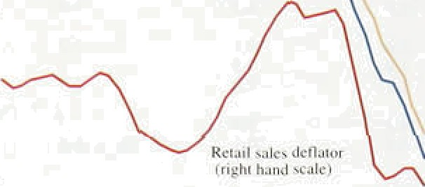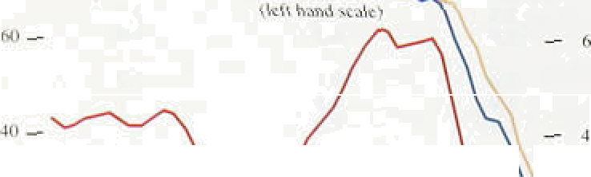

Rei:iil rules iJcnuuir



t’iiari s.c prices of domestic manufactured foods rose by 1.4%.

\t hole.salers’ reported rind **esprcted prices tt“BI** (A box in the Feb **r*.*ua*t j*** *.In flatiou Report* discussed the Gislributis e Trades .Surveyl an‹l **pi oducer pricrK** impact of food retailers’ margins on the RPI.) The

„ "“'“’“' ”“"" “” " ' „, implieati:on is that retailers are .facing.increasing costs

for their stock, but are finding it difficult to .pass these higher costs on to consumers. At the.same time, however, food retailers have gofie some way towards containing the costs from their suppliers. Although the output prices of the .foold, ‹drink.an‹i .tolbacco industry are rising tauter than retai1!food1 prices, they are rising much more slowl.y than.!they were during 1.992 and 1993 (they peaked at ñ.59c i.n Jtily last year).



Moreover, the outlook for prices ifi:food manufacturirig given the latest CBI sumey .is more sanguine. the balance of.firms’ intending to raise prices ttas falien

t9s:3 s4 a5 .n6 87 flfl u9 90 91 92 : 93

from +199 in Ql to -3&o in Q2:

Ch4ri 5.7 The’chemicals and textiles industries both report. a Price-cost differential‹•› and capacity utilisation:t°i relati.vely high. number of films, working!,at or above li›‹›d. dPllik and tobaCco ilâanufuEtl2F8FS .capacity .(over 50&r) and both have. a substantial

positive balance of.firms (l.3â ) expeciting to increase prices over the next four months. The sector furthest below capacity is.motor.vehicles, where only, il0&• of firrñs are working at capacity; a balance of.32to of firms,expect to *cut* prices ,over the next four months. The capital goods sectoy is’ similar. two thirds of.firms are..operant:ng below ca:pacify and .l7!& of them expect:

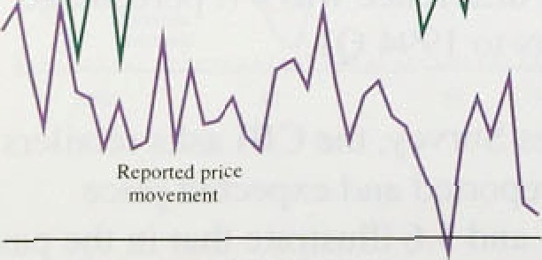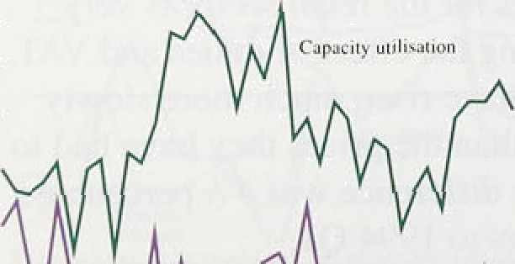

—

- 60



5:.2 Terms of trailé

”In the.pa,st, exchange.rate changes have.produced a much.:greater reaction from import prices than from





###### export prices—in terms both of the speed and the extent

of the:response. But this has not happened in the period

.since sterling’s departure from the ERM. Export and import prices both rose almost immediately by roughly the amount of the depreciation. as would be expected in a small open economy trading in competitive world markets. The subsequent strengthening of the exchange rate was then accompanied by a fall in import prices but

.a further rise in expori prices. As a result, the non-oil terms of trade reached a peak of 105 in August 1992, fell belovi 100 between October and December of that year and then rose to 108 by the end of 1993.

Import and export price changes might affect UK inflation in a number of ways. The impact of import price changes is relatively clear: higher prices increase firms’ input costs, and prices of higher imported consumer goods directly increase RPIX, unless retailers react to the increases. Export prices do not have a direct effect on UK inflation, but they can have indirect effects, for example, through domestic firms’ capacity.



Chart 5.8

**Sterling oil and non-oil commodity prices**

- - 140









Using a UK-weighted sterling index, commodity prices excluding oil rose by over 129a during the first quarter of this year (Chart 5.8); in March, the index was over 7& higher than a year earlier. Because of weak oil prices, the all-commodities index (in which oil has a

559 weight) rose by only 2% during the first quarter. Oil prices are likely to remain low, given OPEC’s failure to agree a price increase, buoyant non-OPEC supply and little prospect of a substantial increase in demand.

The recent increases in non-oil commodity prices have reflected a number of supply shocks. Although the impact of these shocks is fading, a revival in world demand would tend to push up prices further. But the existehce of sizable stocks of several commodities (particularly metals) should help to prevent substantial price rises.

The fall in the value .of sterling since the beginning of this year (over 2% in effective terms by 4 May) will alm9st certainly push up import prices. Whether these ehanges will be passed through to retail prices is less 'certain; at present, retailers appear largely unable to pass on .increases in, their costs.

Wlietlitir movements.i.q.import prices:provide:genuine

iñforrisatiofi.:about'the:.future domestic.price leve!



InFlatiun Rcjxlrt: May 1994

depends chiefly on the cause of the price change. For example, consider a monetary shock,.such as a rise in overseas interest rates. Where prices take.time to.ad)ust to changes in monetary conditions, higher interest rates overseas could be associated with a depreciation of the sterling exchange rate, overshooting its long-run level, and a rise in sterling import prices. In the longer term, however, overseas inflation would fall in response to the earlier monetary tightening, .some of the depreciation of sterling would be reversed, and sterling import prices would return to their initial levels. In general, changes in import prices caused by monetary shocks overseas should have no permanent impact on domestic inflation, as long as. both policy-makers and firms do not misperceive the initial change in import prices as entailing a permanent change.in the aggregate price level.

Alternatively, consider a rise in the relative price of imports caused by an:adverse real shock, such as a reduction in supply pf a particular commodity that the United Kingdom imported and did not produce domestically. In the long run, the rise in impori prices relative to domestic prices would be expected to peTsist, and the real exchange rate would therefore be lower.

Domestic prices would rise somewhat, unless the monetary stance were tightened temporarily, leading to an appreciation or the nominal exchange rate. Otherwise the shock to the real terms of trade would .luive permanent consequences for the aggregate domestic price level and a short-run effect on inflation.

Charl 5.9

**R<tuti\e price nt'** domestic tu imported manut’actured gnods

It is not always possible to tell whether a change in importprices reflects a monetary or a real shock. However,. Chart 5.9 shows that the ratio of the.domestic price of manufactures to the import price of manufactures has, been on an upward trend through the 1970s and 1980s. This suggests that there has.been a degree of persistence in relative.price changes.



Export price changes may have an ihdirect impact on

" UK inflation through.their effect on capacity, utilisation;

_ i if the demand for—ând profitability of—expOrtS .



_p increases, this will push do;mestic .firms,closer to capacity, which could afféct tlieir!dt›mqstie pticiiig

— " behaviour as.UK demand picks up,. To the extent that

_ , UK demand is satisfied from añ ad, tfie upward. pressuré on,prices will be lessened. **In! general„** the link

.betweeii **changes in export** prices.and domestic prirés

###### ,will lie stron er the more ltte pnces!nf traded. goods. am



**Chart 5.10**

Impnrt end export **pricest** › and the effective

**exchange rate**

###### deterinined”in competitive world markets, and the stronger the links between wages and profits in the tradable and non-tradable sectors.

The.rise in export prices over the past 18 months has reflected a widening of exporters’ margins. Bank calculations suggest these are now higher than at any

„, time since 1982. They are also above the margins

— o• earned on domestic sales, increasing the incentive to sell

z

'

„_ "

###### abroad, although the differential between export and

, , domestic margins is still low relative to the levels

—' '• reached in the late 1970s and early 1980s. The increase

, in margins may result from UK firms believing they had



„

frigln hand sealer

###### — no insufficient capacity to meet any additional demand.

More likely, however, firms felt that their margins had

###### !q been squeezed below equilibrium levels during the perlod of ERM membership and took advantage of the lower exchange rate to redress this. In Sweden, where the effective exchange rate depreciated by around twice as much as in the United Kingdom, exporters only raised their home currency price by an amount similar to UK exporters (119o) in the year to September 1993. The increase in margins continued through the period in which the exchange rate has appreciated, with



potentially adverse implications for UK competitiveness.

It is also possible that export prices—and in turn, exporters’ margin were overstated in last year’s statistics, as a result of the introduction of the Intrastat system. According to the CBI, the balance of firms expecting rises in domestic margins has increased by 17 percentage points since 1992 Q3, whereas the balance for export margins has risen by only 15 percentage points.

## 5 3 Su

###### Both domestic and export margins seem to have widened as firms move closer to capacity, though for export margins the increase may not be as much as the official data suggest. This widening is reflected in the

.current high levels of profitability. Retail margins, though, have probably narrowed. It is unlikely that these changes will continue indefinitely. On the production side, current profit levels are likely to attract new capacity as investment recovers. On the retail side, **pricing** has already reflected increased (current and prospectiVe) competition. There are no immediate

cduses for concern in the.behaviour of the terms of trade,

**.although non-oil commodity** price increases, if they

**eontiñue„** could lead to increases in retail prices in **the**

The Bank’s projection of inflation over the next two years is based on the assumption of unchanged

short-term sterling interest rates. This assumption does not imply an unchanged monetary policy stance; for example, if there were to be a positive shock to aggregate demand, unchanged nominal interest rates would imply faster monetary growth. lower real interest rates, and hence a loosening of monetary policy. Nor will it always be consistent with inflation remaining within the target range. The point of assuming unchanged interest rates in the projection is to help

judge what changes in rates may be necessary in order to keep monetary policy on course towards the

medium-term inflation objective. The projection should not be interpreted as the most likely outcome for inflation, all things considered, but rather as what would be likely to happen if interest rates did stay at the assumed level.

**The Bank’s medium-term inflation**

**roiection**

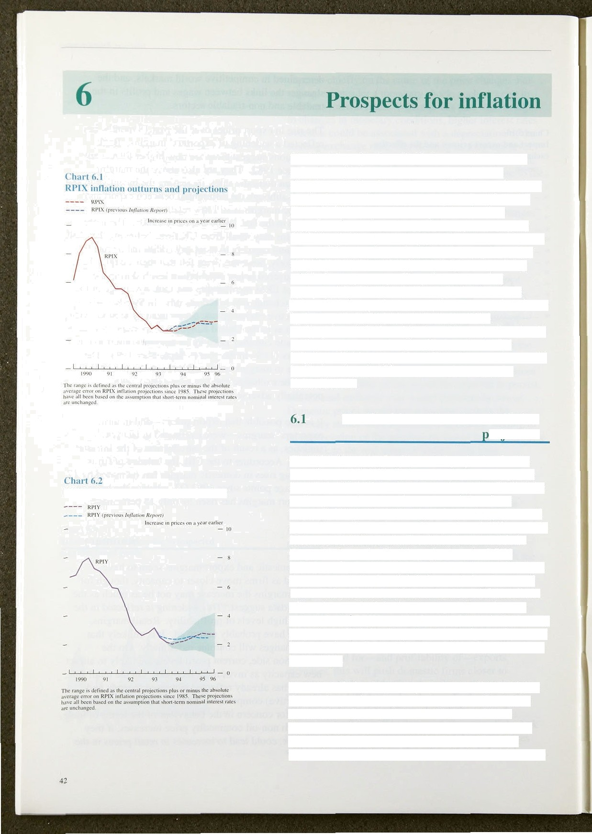

H P 11 irJl1:it i‹›n ‹›ut tr ›”n n rt‹l |j l-‹› jrcfii›n

Chart 6.1 shows the Bank’s central projection for the annual rate of RPIX inflation over the next two years, assuming official interest rates unchanged at 5'/‹%. The exchange rate is assumed to move to bring about uncovered interest parity. Hence the exchange rate will appreciate or depreciate to offset projected differences in interest rates between the UK and overseas markets.

Chart 6.2 shows the Bank's projections for RPIY inflatlon. Compared with the previous *Report,* inflation is now expected to be slightly lower during the rest of 1994. This reflects revisions to estimates of the effects of tax changes, both in the recent past (lowering our calculation of **RPIY)** and in the near future (lowering our projection of **RPIX).** In particular, previous estimates of increases in the Council Tax for 1994/95 have proved to be too high.

In 1995, inflation is now expected to be slightly higher than in the previous *Report* and to be on a flat, rather than shallow downward, trend. The size of these changes should not be exaggerated: they are small in relation to the average error of past projections (as shown by the shaded areas on Charts 6.1 and 6.2) and to



**Chart** €L3.:

**RPIY indefi, current.and previous** projections







.- I4O,O



past movements.in inflation. Chart 6.3 shows that the RPIY price level at the end of 1995 is projected to be

gher .than in the February *Report:* lower



###### marginally more pessimistic view of inflation

developments in 1995. Why is this?

Recent evidence on employment, productivity and earnings suggests that unit labour costs are rising a little faster than expected. In the February *Report,* RPIY inflation was projected to be .around 2’/sha a year and RPIX inflation around 3% a year. These projections were consistent with some moderate increase in average earnings growth. The February projection incorporated such a profile for earnings. But recent data suggest that the labour market is slightly tighter than previously projected. If these pressures are maintained, this could translate into higher inflation next year, as increased unit labour costs feed through into the prices of goods and services bought by firms and, eventually, consumers.

RPIY inflation was unchanged between the fourth quarter of 1993 and the first quarter of 1994. Over the same period, RPIX inflation rose 0.39c. The lower increases in the prices of goods carrying duty and VAT (such as tobacco, alcohol and petrol), at a time when duties were increased, squeezed the margins of retailers of these commodities. The projection assumes that this squeeze is neither reversed nor intensified. As a result, with a projection of a roughly constant quarter-on-quarter change in RPIY inflation, its 12-month growth rate jumps .in the first quarter of 1995.

As discussed in Section 4, .there is little reason to suppose that there has been a significant increase in labo,ur demand, nor is unemployment likely to be close to its long-run equilibrium rate. The size and timing of

.the upturn in earnings growth is therefore difficult to

.explain. It may reflect a fall in labour supply or, perhaps

##### ” .more .likely, that inflation expectations in the labour

.market remain excessive.

##### According to the latest estimates, aggregate demand grew.somewhat faster and output slightly slower in 1993

,thaii suggested by initial data. It is possible that both demand.and output gmwth will weaken slightly in the second half.of t994,.as.tax increases!affect disposable inromes'., But:tbis is.likely to, slowlrecovery. for a..w!hile,.









— 12



— 0

00 (+0 lJ KB 13 10 )% 42 4.8 14 6.0



Source: F• irrcasib of 16 priva'ie .+rcior urgent aiiñn* as 'oF April 1994.

C’hart fi.â

Dist rihutioii ol’ R PI X inflation forecasts

tor t995 QJ

Media. Number oF rorcc»sIs



###### I I I



— 6

I

not to stall it. The direct influence of output growth on the inflation projection has changedtlittle sinee‘the. previous *Report.* There are as yet.few signs of

.impending capacity constraints, with the service sector in particular still depressed.

6 2 t intie a ect he ro e t n

The main change to the projection is the slightly higher inflation for 1995. This is based on extrapolating recent labour market trends. There are obvious risks associated with relying too much .on recent data—but there are also risks associated with ignoring small early warning signs.

In most of the recovery period, real earnings growth has been subdued and, where pay rises have been conceded, firms have responded by bearing down on other costs so as to keep price increases low and profit rates rising. If this behaviour continues, the inflation projection may prove pessimistic. But if the private sector comes to expect higher inflation, this belief could cause employees and firms to push up earnings and prices even faster. A constant monetary policy stance would them imply the need for higher interest rates until inflation expectations were brought back into line. The impact of tax changes on demand.and output is, still uncertain and likely to remain so for much of this year.

A box on page 45. eKamines. the track.:recorfi of the

###### Bank’s medium-term inflation



**6.3 Private sector inflation** forecasts

###### In Section 4, it was noted that employees expectations of inflation have still not come down to existing levels and their one-year-nhead forecasts remain over 4&o.

Private sector forecasting organisations are, on!average, moré consistent with actual developments. Charts 6.4 and 6.S present the distribution of a pañel of 36 forelcasts for’the end’of 1994 and the end of **1995.** They show that the median expectation.of inflation at the,end of 1994.

R0 0.6 KJ K8 .34 10 3.6

42’ 48 G4’ ’&0

###### has fallen from 3.3& to 3.1% since the last *Inflation Report,* but that for the!end of 1993 has nsen. from 3.3& to 3.4 , slighUy afipve.tlie Bank's currént projec**tion.**

**The** April s **eyt.of.fund managers! carried.out by** Smi!th New. CourtiGallup. gives.an:.eâpec@d RPI infiafion ra ' of 3,.2& ::for end-i 994 (up.from 3.1&•'in January) and 3'.9&’.foren‹i-1995!.(up **.from** 3.7& **in Jmuary).,**

A, deterioration in medium to long.-tetm inflation expectations **is‘mirrored in the** inflation **term structure**



### Medium-term,inflation projections: the track record

e m ‘ilding

f.the Ba k’sv record ’of making' adiu ! projections. Tables .1 añd 2 present the successive projections ifor RPIX and RPIY inflation together with tire oiittum. . All.:the pixijections 'assurped! uiichanged iñterest rates; in fact..iriterest.iates were cut froin 69p ‹at i!he .time of.tire



that”the.February 1’99.4..R *ep!o!rt* was; prepared.

The scruple is too.small to draw strong coriclusions, but' the Bank bas tended'to oreypredict inflation, panicularly for me second and fourth quarters of l99:3: Despite this, the .me‹iium-term outlook.has remñined reasonably consistent,. averaging just under 3'/:% for the fourth quarter.of, 1994. and a!si!milar. rates. for. mid-1995.









TheiFeñrñary .1994 assessment did indicate .a clear, if

Bank projeciion was subyectIto.less iJownv iard! revision,



were.surprised fiy!tbe to.w.level of.inflation.actiially'. recorded.in.the fourth.quarter.



Di5triI›cjl i‹›ri ‹ii' It l’l X ii›I1:ilir›n I”‹›rt't'*i*!x I”‹›l” f’J’*ñ U4""







The currcnl projection carries forward a .relatively low inflation prom*ie* through 1994 buto has RPIX inflation returning towards the 3’/i*/o level during 1995..

small, step downwar‹is’ in the medium-term projection, Chart B shows the evolution of RPIX inflation particularly for RPI!¥ initiation,. This. principally reflected projections in 1994 Q4. The Bank’s has been one of the the effects ofi.the Budget..measures; Although the lower projections and the median has tended to converge tendency nf staiistical models:to overpredict !inflation has on. the Bank’s posit.ion. Current projections may not be been. increasingly allowe‹i for in the projections. comparable,.since the Bank’s projection assumes.

constant nominal interest rates whereas.ihe market is

I’al›lc 2

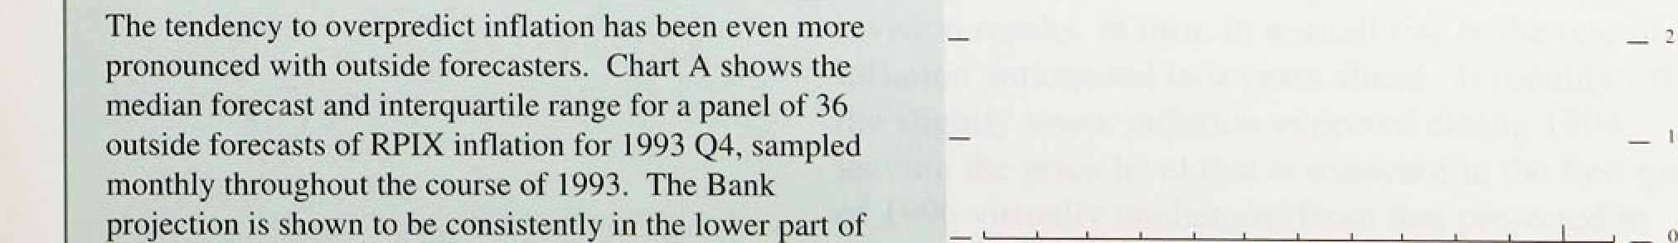

.l 993.

C} Ejcuée’:WATo’ny: RPlC:wAini d £dinQn:Augu•199CPq‹n..

expecting rates to **-rise.**



_,





t°hart fi.h

Inflali‹›n term structure derived frum

gi\I-edycd prices

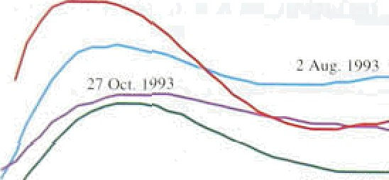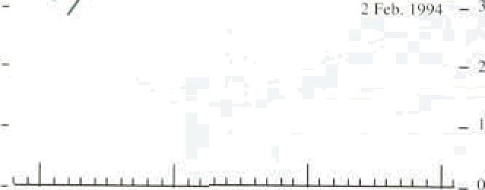

derived from gilt-edged prices. Gilt yields have steadily. risen since the last *In/lation Report* was published—by around 150 basis points at.the short end (two years), around 200 points in the miildle (10 years) and 180 points at the long enñ (25 years) by 4.lay. Real yields, derived from index-linked gilt prices; have also risen but by a smaller amount. Consequently, the inflation term structure shown in Chart 6.6 has risen quite sharply and suggests inflation 8bove 4% for the period from ,1996 to early 20107. As discussed in Se'ction 2, changes in the inflation term structure include changes in the inflation and real interest rate risk premia. Given the recent volatility in financial markets, .the, inflation term structure may be biased as an indicator of inflation expectations. But the changes do suggest that the credibility of the .medium-term inflation target has proved fragile. If it is not restored, and people’s behaviour is based.on higher Inflation expectations„tken containing inflationary pressures will be more difficult.

Market forecasts of inflation are not eomparable with *Inflation Report* medium-term projecltions because they do not assume constant nominal short-term interest rates. Since the February 1993 *Report,* base rates have fallen from 6% to 5'/•%, and for most of the time the market has generally expected either no immediate change or cuts in the near future. But now market projections are for interest rates to.rise. Initially this shou!d raise

market **RPI** forecasts, since. the housing costs element in the ifidex would be increased. The short-term effect on **RPIX** is not clear; but i.n the medium term market forecasts of inflationiought on average to!ñe .lowerlthañ the Bank’s projections, given the di.ffergnce in interest rate assumptions.

 

Inflation fell again *in* the first quarter of this year. Since the February Inflafion fieyorf, inflation—as measured by the Bank’s RPIY measure, which excludes the impact of higher excise duties—has fallen below 2%. Even taking indirect taxes into account, inflation in March was in the lower half of the Government’s target range. At the same time, recovery in output has continued at a

moderate rate and unemployment has fallen further.

The relevance of the latest inflation data for monetary poliry lies primarily in the information that they provide about the future course of inflation. In large part, the fall in inflation in the first quarter of this year reflected a squeeze in retail margins. It is likely that this reduction in margins wih persist indefinitely. But it is much less evident that there will be a further squeeze in retail margins. This implies that inflation during 1994 will be lower than previously anticipated—consistent with the survey evidence on price intentions—but will rise in the first quarter of 1995, as the reduction earlier this year drops out of the 12-month comparison.

Since changes in monetary policy take time to affect output, employment and inflation, it is necessary to form a judgment about the direction in which inflation is headed over the next two years or so. Although there has been virtually no change in the Bank’s projection of inflation in the early part of 1995, there has been a marginal:change in the projection for two years ahead.

There.are two reasons for this. First, the projection is based on the assumption of unchanged short-term interest rates—5'/•9r compared with 5'Uma at the time of the February *Report,* Second, over the past quarter average earnings have started to rise a little faster, and sooner, than had previously been anticipated. This has led to a marginal upward revision in the central projection for earnings growth over the next year or so. On the assumption of unchanged interest rates, this revision results, in turn, in a small rise in the rate of inflation anticipated two years ahead. It roughly offsets the slightly.lower inflation expected during 1994,

.leaving tlie price level that is expected in the first quartet

**of 1996 virtually unchanged** from that projected in

**!February,** On'the assumptiqn of unchanged interest

„ .fates,! the most **likely.outcome .for RPIX.inflation** two ye s lience is..3&m3'/i%,. aqd.for RPIY .inflation just



Inflation Report: May 1994

under 3&». There are, of course, 1arge‹margins of error in any such projection, but the lags.between.changes,in interest rates and thefr impact on inflation mean that monetary policy hasl to be based on a forward-looldhg assessment of inflation.

###### The main risks to the inflation outlook are threefold..

First,.rates of monetary growth—both narrow and

.broad—have continued to increase. For the moment, they do not pose a threat to the inflation target. But if they continue to increase in the months ahead, the implications for inflation would be more disturbing.

Second, inflation expectations have risen.and are no longer coming down into line with the inflation target. Independent forecasters, the .Bank's industrial contacts and financial markets now all exiiibit higher inflation eKpectations tlian at the time of the February *Report.* Expectations affect behaviour, and an expectation of higher inflation can make it more difficult to achieve the combination of low inflation and output expansion permitted by the current growth of nominal demand.

Third is the rise in the growth of underlying average earnings from 3% in November.of last year,to 3'/the in February, and.possibly higher in March—perhaps an early reflection of a behavioural response to changed expectations. Pay:developments will need to be monitored closely. Higher wages do not cause

###### .inflation—provided that they are not accommodated by

monetary policy. But if policy is expected to accommodate.higher levels of wages:and prices, that expectation can in itself lead to highef wage bargains and settlements. A belief that the inflation target will be met should help to restrain the rise in earnings as the economy recovers. That belief must be reinforced by adherence to a firm monetary stance.



